
Syrian Private university
Faculty of Engineering
Department of Informatics Engineering
Artificial intelligence and data science

Intelligent Arabic Legal Advisor
(Graduation Project 2) prepared to obtain the degree of B.Sc. in the Department of Artificial Intelligence Engineering and Data Science

Prepared by:
Bayan alraheel
Mariam abd alsalam
Supervised by:
Dr. Maisaa abo qasem
Eng. Wesam alsohle

Academic Year 2026 / 1448هـ

Supervisor certification

I certify that the preparation of this project entitled Intelligent Arabic Legal Advisor, prepared by Bayan alraheel and Mariam abdalsalam was made under my supervision at Department of Artificial intelligence & data science as part of the Requirements for the fulfillment of the Bachelor Degree in Artificial intelligence and data science .

Name: Signature: Date:

Abstract

This project aims to develop an intelligent legal advisor system that helps users access relevant legal information by asking questions in natural language. The importance of this project comes from the difficulty of manually searching long and complex legal texts, as well as the limitations of traditional keyword-based search methods. The proposed system relies on Natural Language Processing, text embeddings, vector databases, and large language models to retrieve the legal articles most relevant to the user’s question and generate a clear answer based on the retrieved legal texts.
The proposed solution converts legal texts into numerical representations using embedding models and stores them in a vector database that supports semantic search. When a legal question is submitted, the system analyzes the question, retrieves the most relevant legal passages, and uses a language model to generate the final answer. The system is intended to support lawyers, students, researchers, and non-specialized users by simplifying access to legal information and reducing search time, while emphasizing that it is an assistive tool and not a replacement for professional legal consultation.
Keywords: Intelligent Legal Advisor, Natural Language Processing, Semantic Search, Retrieval-Augmented Generation, Arabic Legal Texts.

الملخص

يهدف هذا المشروع إلى بناء نظام مستشار قانوني ذكي قادر على مساعدة المستخدمين في الوصول إلى المعلومات القانونية المناسبة من خلال طرح الأسئلة باللغة الطبيعية. تنبع أهمية المشروع من صعوبة البحث اليدوي داخل النصوص القانونية الطويلة والمعقدة، إضافة إلى محدودية البحث التقليدي المعتمد على الكلمات المفتاحية فقط. يعتمد النظام المقترح على تقنيات معالجة اللغة الطبيعية، وتمثيلات النصوص الرقمية، وقواعد البيانات المتجهية، ونماذج اللغة الكبيرة من أجل استرجاع المواد القانونية الأكثر ارتباطًا بسؤال المستخدم وتوليد إجابة واضحة مبنية على النصوص المسترجعة.
يعتمد الحل المقترح على تحويل النصوص القانونية إلى تمثيلات رقمية باستخدام نماذج Embeddings، ثم تخزينها في قاعدة بيانات متجهية تسمح بالبحث الدلالي. عند إدخال سؤال قانوني، يقوم النظام بتحليل السؤال واسترجاع المقاطع القانونية المناسبة، ثم يستخدم نموذجًا لغويًا لتوليد إجابة نهائية مفهومة. يهدف هذا النظام إلى دعم المحامين والطلاب والباحثين والمستخدمين غير المتخصصين من خلال تسهيل الوصول إلى المعلومات القانونية وتقليل زمن البحث، مع التأكيد أن النظام يمثل أداة مساعدة ولا يغني عن الاستشارة القانونية المتخصصة.
الكلمات المفتاحية: المستشار القانوني الذكي، معالجة اللغة الطبيعية، البحث الدلالي، التوليد المعزز بالاسترجاع، النصوص القانونية العربية

Table of Contents

Abstract iii
الملخص iv
Table of tabels ix
Table of Figures ix
Table of Equations x
List of Abbreviations xi
List of Symbols xii
Chapter 1 1
Introduction 1
1.1 Introduction 2
1.2 Research Problem 3
1.3 Research Objectives 3
1.4 Research Contribution 4
1.5 Beneficiaries of the Research 5
1.6 Thesis Organization 5
Chapter 2 7
Theoretical Background 7
2.1 Introduction 8
2.2 Natural Language Processing 8
2.3 Arabic Legal Text Processing 9
2.4 Text Preprocessing 10
2.5 Text Segmentation and Chunking 10
2.6 Text Embeddings 11
2.6.1 Why Embeddings Are Important for Legal Search 11
2.7 Semantic Search 12
2.8 Vector Databases 12
2.9 Information Retrieval 13
2.10 Retrieval-Augmented Generation 13
2.11 Large Language Models 14
2.12 Hallucination in Legal AI Systems 15
2.13 Legal Question Answering 15
2.14 General Architecture of the Proposed System 16
2.15 Advantages of the Proposed Theoretical Approach 17
2.16 Chapter Summary 17
Chapter 3 18
Literature Review 18
3.1 Introduction 19
3.2 Arabic RAG Systems 19
3.3 Comparative Analysis of Related Studies 21
3.4 Arabic Embedding Studies 23
3.5 Discussion 24
3.6 Research Gap and Proposed Innovation 25
3.7 Chapter Summary 26
Chapter 4 27
Research Methodology 27
4.1 Introduction 28
4.2 Proposed System Overview 28
4.3 Dataset Used in the Proposed System 29
4.4 Dataset Description 31
4.5 Overall System Architecture 32
4.6 Data Preparation Pipeline 33
4.7 Query and Answer Generation Pipeline 35
4.8 RAG Pipeline for Legal Questions 37
4.9 Complete RAG Pipeline 38
4.10 Detailed System Workflow 39
4.11 Data Preprocessing 41
4.12 Text Segmentation 42
4.13 Embedding Generation 42
4.14 Vector Database Storage 43
4.15 Semantic Retrieval and Hybrid Retrieval 44
4.16 Answer Generation 45
4.17 Tools and Technologies Used 46
4.18 Models Used in the Proposed System 46
4.19 Chapter Summary 47
Chapter 5 49
Results and Evaluation 49
5.1 Introduction 50
5.2 Evaluation Dataset 50
5.3 Query Cleaning and Rewriting 51
5.3.1 Query Cleaning Function 52
5.3.2 Query Rewriting Decision Function 53
5.3.3 Query Rewriting Function 54
5.4 Retrieval Evaluation 54
5.5 Recall@K Metric 55
5.6 Retrieval Evaluation Results 55
5.7 Per-Topic Recall@6 56
5.8 Out-of-Scope Rejection Evaluation 57
5.9 LLM-as-a-Judge Evaluation 57
5.10 LLM-as-a-Judge Metrics 58
5.11 Sample LLM Judge Results 59
5.12 Intent Classification Evaluation 60
5.13 Intent Classification Metrics 60
5.14 Intent Classification Error Analysis 62
5.15 System Interface Results 62
5.16 Overall Evaluation Summary 64
5.17 Discussion of Results 65
5.18 Chapter Summary 65
Chapter 6 66
Conclusion and Future Work 66
6.1 Introduction 67
6.2 General Conclusion 67
6.3 Main Achievements 68
6.3.1 Building an Arabic Legal Question-Answering System 68
6.3.2 Preparing a Syrian Legal Corpus 68
6.3.3 Applying Query Cleaning and Rewriting 68
6.3.4 Implementing Semantic and Hybrid Retrieval 68
6.3.5 Using Reranking to Improve Evidence Selection 68
6.3.6 Evaluating the System with Verified Questions 69
6.3.7 Achieving Strong Evaluation Results 69
6.4 Discussion of Results 69
6.5 Challenges 70
6.5.1 Arabic Language Complexity 70
6.5.2 Legal Language Complexity 70
6.5.3 Colloquial User Questions 70
6.5.4 Mixed-Intent Questions 70
6.5.5 Retrieval Completeness 70
6.5.6 Legal Responsibility 70
6.6 Limitations 71
6.7 Future Work 71
6.7.1 Expanding the Legal Corpus 71
6.7.2 Improving Intent Classification 71
6.7.3 Enhancing Query Rewriting 71
6.7.4 Adding Citation Display in Answers 72
6.7.5 Adding User Feedback 72
6.7.6 Improving Legal Template Support 72
6.7.7 Supporting More Evaluation Cases 72
6.7.8 Adding Multilingual Support 72
6.7.9 Deployment and Security Improvements 72
6.8 Final Conclusion 72
References 74

Table of tabels

Table 1: Main Text Preprocessing Steps Used in the Proposed System 10
Table 2:RAG process 14
Table 3 :The general pipeline of the Intelligent Legal Advisor 16
Table 4 :Comparison of Arabic RAG Systems 21
Table 5 :Comparative Analysis of Related Studies 23
Table 6 :Comparison of Arabic Embedding Studies 24
Table 7 :Datasets Used in the Proposed System 31
Table 8 :General Dataset Structure 32
Table 9 :Detailed Workflow of the Proposed System 40
Table 10:Text Preprocessing Steps 41
Table 11:Example of a Structured Legal Article 42
Table 12:Vector Database Record Structure 43
Table 13:Hybrid Retrieval Components 44
Table 14 :Tools and Technologies Used 46
Table 15:Models Used in the Proposed System 47
Table 16 :Evaluation Question Categories 51
Table 17:Query Cleaning Operations 52
Table 18 :Query Rewriting Decision Logic 53
Table 19 :Query Rewriting Examples 54
Table 20:Retrieval Evaluation Results 56
Table 21:Per-Topic Recall@6 Results 57
Table 22 :Out-of-Scope Rejection Results 57
Table 23 : LLM-as-a-Judge Evaluation Results 58
Table 24:Sample Answer Quality Results 59
Table 25 :Intent Classification Results 61
Table 26: Intent Accuracy by Difficulty 61
Table 27:Examples of Intent Classification Errors 62
Table 28 :Overall Evaluation Summary 64
Table 29 :The final result summary 70

Table of Figures

Figure 1:Overall Architecture of the Proposed Smart Legal Adviser System 32
Figure 2:Data Preparation Pipeline 33
Figure 3:Query and Answer Generation Pipeline 36
Figure 4:RAG Pipeline Used for Answering Legal Questions 38
Figure 5:Complete RAG Pipeline of the Proposed System 39
Figure 6 :Text-to-Embedding Process 43
Figure 7 :Answer Generation Using Retrieved Context 45
Figure 8 :Main User Interface 63
Figure 9 :Legal Question Answering Example 63
Figure 10: user question in slang arabic 64

Table of Equations

Equation 1:Recall@K 55
Equation 2 :Per-Topic Recall@6 56
Equation 3 :Out-of-Scope Rejection Rate 57
Equation 4 :Answer Average Score 58
Equation 5:Overall Average 58
Equation 6 :Intent Classification Accuracy 60
Equation 7:Rules-Layer Resolution Rate 60
Equation 8: LLM-Layer Resolution Rate 61

List of Abbreviations

المصطلح (Abbreviation) | المعنى الكامل (Full Description)
RAG | Retrieval-Augmented Generation
LLM | Large Language Model
NLP | Natural Language Processing
BM25 | Best Matching 25
E5-Large | Multilingual Embedding Model
BGE Reranker | Bigai Generalized Embedding Reranker
OCR | Optical Character Recognition
RAGAS | RAG Assessment
ChromaDB | Vector Database used for indexing legal chunks
CUDA | Compute Unified Device Architecture

List of Symbols

Symbol | Description | Used In
Q | Represents the user query submitted to the system. | Chapter 4, Chapter 5
D | Represents a legal document, legal article, or legal passage retrieved from the legal corpus. | Chapter 4, Chapter 5
E(Q) | Embedding vector of the user query after query cleaning and embedding generation. | Chapter 4
E(D) | Embedding vector of a legal article or passage stored in the vector database. | Chapter 4
cos(θ) | Cosine similarity used to measure semantic similarity between the query embedding and legal-text embeddings. | Chapter 2, Chapter 4
K | Number of top retrieved results considered in retrieval evaluation, such as K = 1, 3, 6, or 10. | Chapter 5
Top-K | The first K retrieved legal passages returned by the retrieval system. | Chapter 5
G | The set of gold legal article keys expected for a verified evaluation question. | Chapter 5
Rₖ | The set of legal articles retrieved by the system within the Top-K results. | Chapter 5
Recall@K | Retrieval metric that checks whether at least one correct legal article appears within the Top-K retrieved results. | Chapter 5
N | Total number of evaluated legal questions. | Chapter 5
S_semantic | Semantic retrieval score based on embeddings and vector similarity. | Chapter 4, Chapter 5
S_lexical | Lexical retrieval score based on keyword matching using BM25. | Chapter 4, Chapter 5
RRF | Reciprocal Rank Fusion, used to combine ranked results from semantic and lexical retrieval. | Chapter 4, Chapter 5
A | Accuracy score assigned by the LLM-as-a-Judge evaluator. | Chapter 5
C | Completeness score assigned by the LLM-as-a-Judge evaluator. | Chapter 5
H | No Hallucination score assigned by the LLM-as-a-Judge evaluator. | Chapter 5
L | Clarity score assigned by the LLM-as-a-Judge evaluator. | Chapter 5
Avg_answer | Average answer-quality score calculated from Accuracy, Completeness, No Hallucination, and Clarity. | Chapter 5
OOS | Out-of-scope questions that are outside the supported legal corpus. | Chapter 5
OOS Rate | Percentage of out-of-scope questions correctly rejected by the system. | Chapter 5
I_correct | Number of correctly classified user intents. | Chapter 5
I_total | Total number of intent classification test cases. | Chapter 5

Chapter 1

Introduction

Introduction
In recent years, Artificial Intelligence has become an important tool for processing, analyzing, and retrieving information from large collections of text. One of the most significant areas affected by this development is Natural Language Processing, which enables computer systems to understand human language and respond to user queries in a meaningful way. These technologies have created new opportunities in many fields, including education, healthcare, administration, and law.
The legal field is one of the domains that can benefit greatly from intelligent text-processing systems. Legal documents are usually long, formal, and complex. They include many articles, conditions, exceptions, and references that require careful reading and interpretation. As a result, searching for a specific legal answer can be time-consuming, especially for students, researchers, or non-specialized users.
Traditional search methods usually depend on exact keywords. However, this approach is often not enough in the legal domain. A user may ask a question using simple language, while the legal text uses formal terminology. In such cases, keyword-based search may fail to retrieve the correct article, even when the answer exists in the legal documents. Therefore, there is a need for a smarter system that can understand the meaning of the user’s question rather than only matching words.
This project proposes an intelligent legal advisor system that receives legal questions in natural language, analyzes them, retrieves the most relevant legal texts, and generates a clear answer based on the retrieved information. The system uses text embeddings, semantic search, vector databases, and large language models to improve the process of accessing legal information.
The purpose of this project is not to replace lawyers or legal experts. Instead, it aims to provide an assistive tool that helps users search legal texts faster, understand legal information more easily, and access relevant legal articles with less effort

Research Problem
The main research problem is the difficulty of quickly and accurately accessing legal information within long and complex legal texts. Legal users often need to search through many articles to find the information related to a specific question. This process requires time, legal knowledge, and familiarity with the correct terminology.
A major limitation of traditional legal search systems is their dependence on keywords. If the user does not use the exact legal term found in the text, the system may not retrieve the correct result. For example, a user may ask a question in simple or informal language, while the legal article is written in formal legal language. This creates a gap between the user’s query and the legal text.
Another challenge is that legal information is often context-dependent. A single question may require more than one article, or it may depend on specific conditions and exceptions. Therefore, an effective system must not only retrieve similar text, but also retrieve legally relevant information that can support the final answer.
Based on this problem, the research question can be formulated as follows:
How can an intelligent legal advisor system be designed to understand legal questions written in natural language, retrieve the most relevant legal articles, and generate accurate answers based on legal texts?

Research Objectives
The main objective of this research is to develop an intelligent legal advisor system that helps users access relevant legal information by asking questions in natural language. The system aims to improve the process of searching within legal texts by using semantic search instead of relying only on keyword matching.
The specific objectives of this project are:
- collect and prepare the legal texts used in the system.
- preprocess and clean the legal texts to make them suitable for computational processing.
- divide legal texts into searchable units, such as articles or passages.
- convert legal texts into numerical representations using embedding models.
- store the embeddings in a vector database for semantic retrieval.
- analyze the user’s legal question and identify its meaning.
- retrieve the most relevant legal articles or passages.
- generate a clear answer based on the retrieved legal texts.
- reduce the limitations of traditional keyword-based search.
- create a system structure that can be expanded in the future to include more laws or legal services.

Research Contribution
The main contribution of this research is the development of an applied model for an intelligent legal advisor system designed for Arabic legal texts, especially Syrian legal texts. This contribution is important because Arabic language processing presents several challenges, such as word variation, morphology, spelling differences, and different ways of expressing the same meaning.
The project combines several technologies into one complete workflow. This workflow begins with legal text preprocessing, then converts the text into embeddings, stores the embeddings in a vector database, retrieves the relevant legal content, and finally generates an answer using a language model. This combination of retrieval and generation makes the system more effective than traditional search methods.
The system also contributes to reducing the time required to search legal documents. Instead of manually reviewing many legal articles, the user can ask a question directly and receive an answer supported by relevant legal text. This can help lawyers, students, researchers, and non-specialized users access legal information more efficiently.
Another contribution of the project is that it applies Retrieval-Augmented Generation in a legal context. This approach helps reduce the risk of generating unsupported answers because the response is based on retrieved legal materials. As a result, the system becomes more controlled and more suitable for a sensitive domain such as law.

Beneficiaries of the Research
Several groups can benefit from the proposed system:
Lawyers and Legal Advisors
Lawyers can use the system to quickly access legal articles related to a specific question or case. This can reduce the time needed for initial legal research.
Law Students
Law students can use the system as an educational tool to understand legal articles and explore the connection between legal questions and legal texts.
Artificial Intelligence Students and Researchers
The project provides a practical example of applying Natural Language Processing and Retrieval-Augmented Generation to Arabic legal texts.
Legal and Administrative Institutions
Legal institutions can benefit from similar systems to improve access to legal and procedural information inside their organizations.
Non-Specialized Users
Ordinary users can use the system to obtain an initial understanding of legal information. However, the system should be used as an assistive tool and not as a substitute for professional legal consultation.
Software Developers
Developers can benefit from the project architecture as a model for building similar intelligent search systems in other specialized domains.

Thesis Organization
This thesis is organized into six chapters.
Chapter One introduces the project, explains the research problem, defines the research objectives, presents the main contribution, identifies the beneficiaries, and describes the structure of the thesis.
Chapter Two presents the theoretical background of the project. It explains the main concepts related to Natural Language Processing, text embeddings, semantic search, vector databases, large language models, and Retrieval-Augmented Generation.
Chapter Three presents the literature review. It discusses previous studies related to Arabic RAG systems, Arabic embedding models, legal AI systems, and intelligent question-answering systems. It also compares these studies and identifies the research gap addressed by this project.
Chapter Four explains the research methodology. It describes the proposed system workflow, including data collection, preprocessing, text segmentation, embedding generation, vector storage, retrieval, and answer generation.
Chapter Five presents the research results. It describes the tools used, the evaluation methods, the output of the proposed system, and the comparison with previous work when applicable.
Chapter Six presents the conclusion. It summarizes the main findings of the research, discusses the challenges faced during the project, and suggests future improvements for the system.

Chapter 2

Theoretical Background

Introduction
This chapter presents the theoretical foundations required to understand the proposed Intelligent Legal Advisor system. The project depends on several concepts from Artificial Intelligence, Natural Language Processing, Information Retrieval, and Large Language Models. These concepts work together to allow the system to receive a legal question written in natural language, understand its meaning, retrieve the most relevant legal texts, and generate a clear answer based on the retrieved legal materials.
The proposed system is based on a Retrieval-Augmented Generation architecture. This architecture combines two main abilities: retrieval and generation. The retrieval part searches for the most relevant legal texts, while the generation part uses a language model to produce the final answer. In the project presentation, the proposed solution includes converting legal texts into embeddings, using Natural Language Processing to analyze legal texts, storing these texts in a vector database for semantic search, and using a language model to generate the final response.
The theoretical concepts discussed in this chapter include Natural Language Processing, Arabic legal text processing, text preprocessing, embeddings, semantic search, vector databases, Retrieval-Augmented Generation, and Large Language Models. These concepts form the scientific and technical basis of the proposed system.

Natural Language Processing
Natural Language Processing, commonly abbreviated as NLP, is a field of Artificial Intelligence that focuses on enabling computers to understand, analyze, and generate human language. Unlike structured data, natural language is complex because it contains grammar, ambiguity, context, synonyms, and different ways of expressing the same meaning.
In this project, NLP is important because users do not interact with the system using database commands or exact legal keywords. Instead, they ask questions in natural language. For example, a user may ask:
ما هي شروط الطلاق؟""
or:
"ما هي المادة القانونية التي تتحدث عن الحضانة؟"
The system must process this question and identify its meaning before searching the legal corpus. This requires several NLP operations, such as text cleaning, normalization, query understanding, and semantic representation.
NLP is especially important in legal systems because legal language is formal, precise, and often difficult for non-specialists. Legal texts may contain long sentences, technical terms, references to other articles, and conditional phrases. Therefore, an intelligent legal advisor must be able to process both user-friendly language and formal legal language.

Arabic Legal Text Processing
Arabic text processing introduces additional challenges compared with many other languages. Arabic words can appear in several forms because of prefixes, suffixes, gender, number, and grammatical structure. In addition, Arabic text may be written with or without diacritics, and the same letter may appear in different forms, such as “أ”, “إ”, “آ”, and “ا”.
Legal Arabic adds another level of complexity because it uses specialized terminology and formal sentence structures. A legal article may use terms that are not common in everyday language. For example, legal expressions related to custody, inheritance, marriage, divorce, notification, appeal, and jurisdiction may have specific meanings that must be preserved during processing.
For this reason, Arabic legal text processing usually requires normalization and cleaning before the text is used in retrieval. The system may need to remove diacritics, unify letter forms, remove unnecessary symbols, and keep important legal terms unchanged. The project code also reflects this need by including Arabic query cleaning and rewriting rules that preserve legal terms such as notification, appeal, jurisdiction, and execution.

Text Preprocessing
Text preprocessing is the process of preparing raw text before it is used by the system. Raw legal documents may contain formatting noise, page numbers, extra spaces, punctuation issues, or inconsistent writing forms. If these issues are not handled, they can reduce retrieval accuracy.
In this project, preprocessing is important because the system depends on matching user questions with legal articles or legal passages. A small difference in spelling or formatting may affect the retrieval result. Therefore, preprocessing helps make the legal corpus cleaner and more consistent.
Common preprocessing steps include:
Step | Purpose
Text cleaning | Removing unnecessary symbols, formatting noise, and repeated spaces
Normalization | Unifying Arabic letter forms and removing diacritics
Segmentation | Dividing long legal documents into smaller searchable units
Metadata extraction | Storing article number, law name, and topic information
Query cleaning | Preparing the user question before retrieval
Table 1: Main Text Preprocessing Steps Used in the Proposed System
In the proposed project workflow, the legal texts are extracted, cleaned, divided into legal passages, converted into embeddings, and stored in a vector database.

Text Segmentation and Chunking
Text segmentation, also known as chunking, is the process of dividing long documents into smaller parts. In the legal domain, the most natural unit of segmentation is usually the legal article. However, some articles may be long and contain several ideas, while others may be short and direct.
Segmentation is important because retrieval systems work better when each searchable unit contains a focused meaning. If the text segment is too large, it may contain unrelated information. If it is too small, it may lose the context needed to understand the legal meaning.
For legal texts, a good chunking strategy should preserve:
- The article number.
- The original legal text.
- The law name.
- The topic or category.
- Any relation to nearby or referenced articles.
In this project, chunking allows the system to retrieve legal materials more accurately. Instead of searching a complete legal book as one large text, the system searches smaller legal units. This improves both speed and relevance.

Text Embeddings
Text embeddings are numerical representations of text. They convert words, sentences, or documents into vectors. A vector is a list of numbers that represents the meaning of the text in a mathematical space.
The main idea behind embeddings is that texts with similar meanings should have similar vectors. For example, the question:
“What are the rules of child custody?”
should be close in vector space to legal articles related to custody, even if the exact words are not identical.
This is one of the most important differences between traditional keyword search and semantic search. Keyword search only looks for exact or near-exact word matches. Embedding-based search looks for similarity in meaning.
In the proposed system, legal texts are converted into embeddings and stored inside a vector database. This allows the system to retrieve legal texts based on semantic similarity rather than only keyword matching. The PowerPoint specifically identifies embeddings as a core part of the proposed solution.

Why Embeddings Are Important for Legal Search
Embeddings are useful in legal search because users may ask questions using different words from those used in the legal text. For example, a user might ask about “wife expenses,” while the legal text may use the term “maintenance” or “alimony.” A keyword-based system may miss the relation, but an embedding-based system can identify that these concepts are related.
In Arabic legal texts, embeddings are especially useful because of word variation and morphology. The same legal concept may appear in different forms depending on the sentence. Therefore, semantic representation helps improve the ability of the system to retrieve relevant legal articles.

Semantic Search
Semantic search is a search method that retrieves information based on meaning rather than exact word matching. It uses embeddings to compare the user’s question with stored text vectors.
The general process of semantic search is as follows:
- The user enters a question.
- The question is converted into an embedding.
- The system compares the question embedding with stored legal-text embeddings.
- The most similar vectors are retrieved.
- The corresponding legal texts are returned as relevant results.
This approach is suitable for the Intelligent Legal Advisor because legal questions are often expressed in natural language. The user does not need to know the exact legal wording. Instead, the system attempts to understand the meaning of the question and retrieve legally relevant passages.
Semantic search improves the system’s ability to handle paraphrased questions, simple language, and different expressions of the same legal concept.

Vector Databases
A vector database is a database designed to store and search vectors efficiently. Since embeddings are represented as vectors, a vector database is needed to store the embeddings of legal texts and retrieve the most similar ones when the user asks a question.
Traditional databases are usually designed for structured data, such as names, numbers, and dates. A vector database, however, is designed for similarity search. It can quickly find vectors that are close to the query vector.
In the proposed system, the legal text embeddings are stored in a vector database. When a user submits a question, the system converts the question into a vector and searches the database for the closest legal text vectors. This makes semantic retrieval possible.
The use of a vector database is one of the main components of the proposed solution presented in the PowerPoint, where legal texts are stored in a vector database to support semantic search.

Information Retrieval
Information Retrieval is the process of finding relevant information from a large collection of documents. In this project, the document collection consists of legal texts, legal articles, or legal passages.
The goal of retrieval is to select the most relevant legal texts for a given user question. A good retrieval system should satisfy two main conditions:
- It should retrieve relevant legal articles.
- It should avoid retrieving unrelated articles.
Information retrieval can be performed using different approaches. Traditional retrieval uses keyword matching. Semantic retrieval uses embeddings. Some advanced systems combine both methods to improve accuracy.
In legal applications, retrieval quality is critical. If the system retrieves the wrong legal text, the generated answer may also be wrong. Therefore, retrieval is one of the most important stages in the Intelligent Legal Advisor system.

Retrieval-Augmented Generation
Retrieval-Augmented Generation, abbreviated as RAG, is an architecture that combines document retrieval with text generation. Instead of asking a language model to answer only from its internal knowledge, the system first retrieves relevant documents and then provides them to the model as context.
The RAG process can be summarized as follows:
Stage | Description
User question | The user asks a question in natural language
Query processing | The system cleans and analyzes the question
Retrieval | The system retrieves relevant legal texts from the database
Context construction | Retrieved texts are provided to the language model
Answer generation | The model generates an answer based on the retrieved texts
Table 2:RAG process
RAG is very suitable for legal applications because legal answers must be grounded in reliable sources. A general language model may generate fluent but unsupported answers. In contrast, a RAG system reduces this risk by forcing the generation process to depend on retrieved legal texts.
The project presentation classifies the proposed solution as a system that retrieves relevant legal material and uses a language model to generate the final answer. This matches the basic structure of RAG.

Large Language Models
Large Language Models, or LLMs, are AI models trained on large amounts of text. They can understand questions, summarize information, generate explanations, and produce human-like language.
In the proposed system, the language model is used after retrieval. It does not work alone. Instead, it receives the user question and the retrieved legal texts, then generates a final answer based on that context.
This design is important because legal applications require accuracy and traceability. If the model generates an answer without retrieved legal support, the answer may be incorrect or misleading. By using the retrieved legal texts as context, the system becomes more reliable.
The language model is responsible for:
- Reading the retrieved legal passages.
- Understanding the user’s question.
- Combining relevant information.
- Producing a clear legal answer.
- Presenting the answer in understandable language.
However, the model should not be considered a legal authority. It is a tool that helps organize and explain retrieved legal information.

Hallucination in Legal AI Systems
Hallucination is a major problem in language models. It occurs when a model generates information that sounds correct but is not supported by real data. In legal systems, hallucination is especially dangerous because an incorrect legal answer may mislead the user.
For example, a model may invent a legal article, misquote a law, or give a rule that does not exist in the available legal corpus. This is why the proposed system should rely on retrieval before generation.
RAG helps reduce hallucination by grounding the model’s answer in retrieved legal texts. However, RAG does not eliminate the problem completely. The system must still be designed carefully to ensure that the retrieved documents are relevant and that the model does not go beyond the provided context.
To reduce hallucination, the system should follow these principles:
- Retrieve legal texts before generating the answer.
- Provide the retrieved passages clearly to the model.
- Instruct the model to answer only from the retrieved context.
- Avoid inventing article numbers or unsupported legal rules.
- Allow the system to say that no sufficient information was found.

Legal Question Answering
Legal Question Answering is the task of receiving a legal question and producing an answer based on legal sources. This task is more difficult than general question answering because legal answers require precision, context, and source grounding.
A legal question-answering system should understand:
- The legal topic of the question.
- The relevant legal articles.
- The conditions and exceptions in the law.
- The difference between general explanation and legal advice.
- The limits of the available corpus.
The Intelligent Legal Advisor proposed in this project is a legal question-answering system based on RAG. It uses retrieval to find relevant legal passages and generation to produce an answer.
This approach makes the system useful for users who need fast access to legal information, while still keeping the answer connected to legal texts.

General Architecture of the Proposed System
The proposed system can be understood as a pipeline. A pipeline is a sequence of steps where the output of one step becomes the input of the next step.
The general pipeline of the Intelligent Legal Advisor is:
Step | Description
1 | Collect legal documents
2 | Extract legal text from files
3 | Clean and preprocess the text
4 | Divide the text into legal passages
5 | Convert passages into embeddings
6 | Store embeddings in a vector database
7 | Receive the user’s question
8 | Process and understand the question
9 | Retrieve the most relevant legal texts
10 | Generate the final answer using a language model
Table 3 :The general pipeline of the Intelligent Legal Advisor
This workflow corresponds to the algorithm shown in the project presentation, where the system extracts legal texts, cleans them, divides them, converts them into embeddings, stores them in a vector database, receives the user question, retrieves the most related legal texts, and generates the answer using a language model.

Advantages of the Proposed Theoretical Approach
The theoretical approach used in this project provides several advantages.
First, semantic search allows the system to retrieve legal texts based on meaning. This makes the system more flexible than traditional keyword search.
Second, embeddings allow legal texts and user questions to be represented mathematically. This makes it possible to compare them using vector similarity.
Third, vector databases make retrieval faster and more scalable, especially when the number of legal documents increases.
Fourth, RAG improves answer reliability because the generated answer is based on retrieved legal texts instead of only the model’s internal knowledge.
Fifth, the system can be expanded in the future. More laws, legal templates, court procedures, or legal domains can be added by updating the database and embeddings.

Chapter Summary
This chapter explained the theoretical background of the Intelligent Legal Advisor system. It introduced the main concepts needed to understand the project, including Natural Language Processing, Arabic legal text processing, preprocessing, chunking, embeddings, semantic search, vector databases, information retrieval, Retrieval-Augmented Generation, and Large Language Models.
The chapter showed that the proposed system depends on a complete pipeline that starts from legal text preparation and ends with answer generation. The main idea is to convert legal texts into searchable semantic representations, retrieve the most relevant legal passages for each user question, and generate a clear answer based on those passages.
These theoretical foundations prepare the reader for the next chapter, which presents the related studies and compares previous work in Arabic RAG systems, Arabic embeddings, and legal AI applications.

Chapter 3

Literature Review

Introduction
This chapter presents the literature review related to the proposed Intelligent Legal Advisor system. The purpose of this chapter is to study previous research works, compare existing approaches, and identify the research gap that the proposed project aims to address.
The proposed system is related to several research areas, including Arabic Natural Language Processing, Retrieval-Augmented Generation, semantic search, vector databases, Arabic embeddings, and legal text processing. Since the project focuses on Arabic legal texts, the selected studies mainly cover Arabic RAG systems, Arabic embedding models, and legal Artificial Intelligence applications.
The reviewed studies are important because they show the current progress in Arabic language understanding and Arabic question-answering systems. They also show the challenges that still exist, such as Arabic morphology, limited Arabic legal datasets, long legal texts, and the difficulty of producing answers that are grounded in reliable legal sources.
This chapter is organized as follows. Section 3.2 presents previous studies in Arabic RAG systems. Section 3.3 presents a comparative analysis of related studies. Section 3.4 discusses Arabic embedding studies. Section 3.5 presents a discussion of the reviewed works. Section 3.6 identifies the research gap and explains the proposed innovation.

Arabic RAG Systems
Retrieval-Augmented Generation, commonly abbreviated as RAG, has become one of the most important approaches in modern question-answering systems. RAG combines information retrieval with text generation. In this approach, the system first retrieves relevant documents or passages, then uses a language model to generate an answer based on the retrieved information.
This approach is especially useful in legal applications because legal answers should be based on reliable legal texts. A general language model may generate fluent answers, but these answers may not always be accurate or legally supported. Therefore, RAG helps reduce this problem by grounding the generated answer in retrieved legal sources.
Several recent studies have investigated Arabic RAG systems. These studies show that RAG can improve Arabic information retrieval and answer generation. However, they also show that Arabic still has many challenges, such as word variation, dialects, long sentences, and limited specialized datasets.
Table 3.1 compares recent Arabic RAG systems that are relevant to the proposed project. The comparison focuses on the study title, dataset, data size, data type, model architecture, RAG methodology, evaluation criteria, main results, and challenges.
Study Title |  | Dataset Used | Data Size | Data Type | Model / Architecture | RAG Methodology | Evaluation Criteria | Main Results | Challenges
 | Evaluating RAG Pipelines for Arabic Lexical Information Retrieval (2025) | Riyadh Dictionary Arabic Lexical Corpus | ~88,000 lexical entries | Arabic dictionary and lexical texts | GPT-4, SILMA-9B, Aya-8B + AraBERT, E5 | Full RAG: Embedding + Retrieval + Generation | Recall@K, MRR, F1, Accuracy | GPT-4 achieved F1 ≈ 0.90 and Accuracy ≈ 0.82 | Multiple Arabic word forms and weakness of traditional embeddings
 | Exploring Retrieval-Augmented Generation in Arabic (2024) | Diverse Arabic texts, including Modern Standard Arabic and dialects | Medium, not clearly specified | General Arabic multi-domain texts | Multiple LLMs + embedding models | Basic RAG with Arabic linguistic improvements | Precision, Context Relevance | Clear improvement compared with non-RAG answering | Arabic dialects and contextual ambiguity
 | Optimizing RAG Pipelines for Arabic: Systematic Analysis (2025) | Multiple Arabic document QA collections | Large-scale | Long and short Arabic documents | Aya-8B, StableLM + BGE-M3 | Advanced RAG: Chunking + Reranking | Recall, Precision, Faithfulness | Best performance achieved with semantic chunking | Arabic text segmentation and long sentence structure
 | QU-NLP at QIAS: RAG for Islamic Inheritance Reasoning (2025) | Islamic inheritance problems | Several thousand scenarios | Jurisprudential rules and legal-style texts | Fanar-1-9B + LoRA + RAG | RAG + Fine-Tuning | Accuracy, Logical Consistency | Accuracy ≈ 85.8% | Complexity and overlap of Islamic inheritance rules
 | ArabicRAGB Dataset (2025) | ArabicRAGB | ~13,000 examples | Knowledge-based texts, some legal | Not tied to a specific model | Benchmark dataset for RAG evaluation | MRR, Recall@K, BLEU, ROUGE | Suitable dataset for Arabic RAG evaluation | Domain diversity and limited legal specialization
Table 4 :Comparison of Arabic RAG Systems
The comparison shows that Arabic RAG systems can improve information retrieval and answer generation. However, most existing Arabic RAG systems are either general-domain systems or lexical systems. Few studies focus on legal question answering using country-specific legal texts. This creates an important opportunity for the proposed Intelligent Legal Advisor system, which focuses on Arabic legal texts and legal information retrieval

Comparative Analysis of Related Studies
In addition to Arabic RAG systems, several other studies are relevant to the proposed project. Some studies focus on Arabic legal models, some focus on Arabic document retrieval, and others focus on legal judgment prediction. These studies are useful because they show different ways of applying NLP and machine learning to Arabic legal or semi-legal texts.
Table 3.2 provides a broader comparative analysis of related studies. The comparison includes the input data, output or goal, approach, architecture, evaluation criteria, results, resolved limitations, and unresolved limitations.

Paper Title and Year | Input Data | Output / Goal | Approach | Architecture | Evaluation Criteria | Results | Resolved Limitation | Unresolved Limitation
Evaluating RAG Pipelines for Arabic Lexical IR (2025) | Riyadh Dictionary, about 88,000 entries | Retrieval and processing of lexical information | Full RAG: Retrieval + Generation | GPT-4, SILMA-9B, AraBERT | Recall@K, MRR, F1, Accuracy | Accuracy ≈ 82%, F1 ≈ 0.90 | Improved access to Arabic lexical information | Arabic word variation and weak traditional embeddings
AraLegal-BERT: Pretrained Legal Model (2022) | Millions of Arabic legal documents | Legal text classification | Pre-training on specialized legal data | BERT-based AraLegal-BERT | Legal classification accuracy | Better performance in legal tasks | Improved understanding of Arabic legal terminology | Requires large training resources and does not provide RAG-based answering
Optimizing RAG Pipelines for Arabic (2025) | Arabic long and short documents | Improving Arabic RAG performance | Advanced RAG with chunking and reranking | Aya-8B, BGE-M3 | Recall, Precision, Faithfulness | Better performance with semantic chunking | Better processing of long Arabic documents | Difficulty of Arabic sentence segmentation
QIAS: RAG for Islamic Inheritance Reasoning (2025) | Islamic inheritance problems and rules | Solving inheritance reasoning problems | RAG + Fine-Tuning | Fanar-1-9B + LoRA | Accuracy, Logical Consistency | Accuracy ≈ 85.8% | Applied logical rules to legal-style texts | Complexity and overlap of inheritance rules
Arabic Legal Judgment Prediction (2023) | Thousands of legal cases | Predicting legal judgments | Text processing + statistical classification | Word2Vec + SVM | Prediction Accuracy | Accuracy ≈ 88% | Linked case facts with legal outcomes | Statistical models may lack deep semantic understanding
Table 5 :Comparative Analysis of Related Studies
The comparative analysis shows that existing studies have made progress in Arabic legal text processing and Arabic RAG systems. However, many systems focus on classification, prediction, or general-domain retrieval. The proposed project differs because it aims to build a user-facing legal advisor that retrieves relevant legal articles and generates answers based on them.

Arabic Embedding Studies
Embeddings are a core component of the proposed Intelligent Legal Advisor system. They convert text into numerical vectors that represent meaning. This allows the system to compare the user’s question with legal texts based on semantic similarity rather than exact keyword matching.
Arabic embedding studies are important because Arabic has complex morphology and different writing forms. Arabic words may include prefixes, suffixes, and several variations of the same root. Therefore, good Arabic text representation requires suitable preprocessing, tokenization, and sometimes morphology-aware modeling.
Table 3.3 compares selected Arabic embedding studies. The comparison focuses on the research paper, year, data type, data size, preprocessing method, embedding model, and results.
Research Paper | Year | Data Type | Data Size | Preprocessing | Embedding Model | Results
AraBERT: Transformer-based Model for Arabic Language Understanding | 2020 | General Arabic texts and Arabic Wikipedia | ~3 billion words | Farasa tokenization and diacritics removal | AraBERT | Better performance than multilingual BERT in several Arabic NLP tasks
On the Importance of Tokenization in Arabic Embedding Models | 2021 | Multiple Arabic corpora | ~1 billion words | Advanced tokenization + subwords | Word2Vec + BERT | Improved representation of rare Arabic words
Morphological Word Embedding for Arabic Language | 2022 | General Arabic texts | Hundreds of millions of words | Morphological analysis + diacritics removal | Morphological Embedding | Improved topic detection
AraLegal-BERT: A Pretrained Language Model for Arabic Legal Text | 2022 | Arabic legal texts | Millions of legal documents | Normalization + tokenization | AraLegal-BERT | Better performance in legal classification tasks
Arabic Legal Judgment Prediction | 2023 | Legal cases | Thousands of cases | Tokenization + text cleaning | Word2Vec + SVM | Accuracy ≈ 88%
Table 6 :Comparison of Arabic Embedding Studies
This table shows that Arabic embedding quality depends strongly on preprocessing and tokenization. It also shows that domain-specific models such as AraLegal-BERT can improve performance in legal tasks. This supports the idea of using semantic representation in the proposed project instead of relying only on traditional keyword search.

Discussion
The reviewed studies show that Arabic NLP and Arabic RAG systems have developed significantly in recent years. Arabic RAG studies demonstrate that retrieval-augmented generation can improve answer quality by providing relevant context before generation. This is especially useful in domains where factual accuracy is important, such as law.
The studies also show that chunking and reranking can improve retrieval performance. This is important for legal texts because legal documents are often long and contain complex sentence structures. A single legal article may include several conditions, exceptions, and references. Therefore, dividing legal documents into meaningful searchable units is necessary for accurate retrieval.
The Arabic embedding studies show that Arabic text representation is not a simple task. Arabic morphology, spelling variation, and tokenization affect the quality of embeddings. This means that preprocessing is an essential step before generating embeddings or performing semantic search.
Legal AI studies such as AraLegal-BERT and Arabic Legal Judgment Prediction show that specialized legal data improves model performance. However, these studies mainly focus on legal classification or judgment prediction. They do not provide a complete legal question-answering system based on retrieval and generation.
Another important observation is that most reviewed systems are not designed specifically for Syrian legal texts. Arabic legal systems differ from one country to another. Therefore, a general Arabic legal model may not be sufficient for answering questions related to Syrian law. This supports the need for a specialized system that works with the legal corpus used in this project.

Research Gap and Proposed Innovation
Based on the reviewed studies, several research gaps can be identified.
First, many Arabic RAG studies focus on general Arabic text or lexical data rather than legal texts. Although these studies show that RAG is useful for Arabic, they do not fully address the requirements of legal information retrieval.
Second, several Arabic legal AI studies focus on classification or judgment prediction. These tasks are useful, but they do not directly help users ask legal questions and receive answers grounded in legal articles.
Third, most existing Arabic legal systems are not specialized for Syrian legal texts. Since legal rules differ between countries, a legal advisor system should be connected to the specific legal corpus it uses.
Fourth, some systems depend heavily on language models without strong retrieval grounding. In the legal domain, this can be dangerous because the model may generate unsupported or incorrect information. The proposed project reduces this risk by retrieving legal texts before generating the answer.
Fifth, Arabic legal texts require careful preprocessing, semantic representation, and retrieval design. Arabic morphology, spelling variation, and long legal sentences can reduce system performance if they are not handled properly.
The proposed innovation of this project is the development of an Intelligent Legal Advisor system that combines Arabic legal text processing, embeddings, vector database storage, semantic search, and Retrieval-Augmented Generation. The system receives a legal question from the user, retrieves relevant legal materials, and generates a clear answer based on the retrieved texts.
Unlike general Arabic RAG systems, the proposed system focuses on legal information. Unlike legal classification systems, it provides direct question answering. Unlike general language models, it grounds the answer in retrieved legal text. Therefore, the proposed system is more suitable for legal information access, legal education, and legal research support.

Chapter Summary
This chapter reviewed previous studies related to Arabic RAG systems, Arabic embeddings, and Arabic legal AI. The reviewed works showed that RAG improves Arabic question answering, semantic chunking improves retrieval from long documents, and domain-specific legal models improve legal text understanding.
Three comparison tables were presented. Table 3.1 compared Arabic RAG systems. Table 3.2 provided a broader comparative analysis of related studies. Table 3.3 compared Arabic embedding studies. These tables showed that existing work still has limitations, especially in relation to Syrian legal texts, retrieval-grounded legal answer generation, and complete Arabic legal advisor systems.
Based on these limitations, the proposed project aims to fill the research gap by building an Intelligent Legal Advisor system that retrieves relevant legal texts and generates answers grounded in those texts.
The next chapter presents the research methodology and explains the proposed system pipeline in detail, including data preparation, preprocessing, embeddings, vector database storage, retrieval, and answer generation.

Chapter 4

Research Methodology

Introduction
This chapter presents the research methodology used to design and implement the proposed Smart Legal Adviser system. The main objective of the system is to receive legal questions written in natural Arabic language, retrieve the most relevant legal texts from the available legal corpus, and generate a clear answer based on the retrieved legal information.
The methodology is based on a Retrieval-Augmented Generation (RAG) approach. RAG combines information retrieval with answer generation. Instead of depending only on the internal knowledge of a language model, the system first searches the legal corpus, retrieves relevant legal passages, and then uses these passages as context to generate the final answer.
The proposed methodology consists of two main stages. The first stage is the offline indexing stage, where legal documents are collected, cleaned, segmented, converted into embeddings, and stored in a vector database. The second stage is the online question-answering stage, where the user question is processed, relevant legal texts are retrieved, and the final answer is generated using a language model.
This methodology is suitable for legal applications because legal answers must be grounded in legal sources. The system is designed to reduce unsupported answers by making the language model depend on retrieved legal evidence.

Proposed System Overview
The proposed system is an intelligent legal question-answering system designed for Arabic legal texts. It allows the user to ask a legal question in natural language, then retrieves the most relevant legal materials and generates a response based on the retrieved texts.
The system is designed to reduce the limitations of traditional keyword-based search. Traditional search depends mainly on exact word matching, which may fail when the user uses different wording from the legal text. In contrast, the proposed system uses semantic search, which retrieves legal passages based on meaning rather than exact keywords.
The proposed system consists of the following main components:
- User interface.
- FastAPI backend.
- Intent classifier.
- Legal corpus.
- Hybrid retrieval.
- Reranking module.
- Vector database.
- LLM layer.
- Final answer generation.
The system receives the user request, identifies its intent, retrieves the relevant legal content when needed, reranks the retrieved passages, and sends the strongest evidence to the language model to generate a grounded answer.

Dataset Used in the Proposed System
The legal corpus used in this project consists of three main Syrian legal sources:
- Syrian Personal Status Law.
- Syrian Civil Law.
- Syrian Penal Code.
In addition to these three legal files, the system also uses a legal templates dataset. These templates support legal-document drafting and help identify required attachments for some legal procedures.
The three law files represent the main knowledge base of the system. Each law is processed into smaller searchable legal units, usually legal articles. These articles are then converted into embeddings and stored in a vector database to support semantic retrieval.
Dataset | Language | Data Type | Approximate Size | Format | Purpose in the System
Syrian Personal Status Law | Arabic | Legal articles | 308 articles | Text / JSON | Used for questions related to marriage, divorce, custody, alimony, lineage, inheritance, and family law
Syrian Civil Law | Arabic | Legal articles | 1130 articles / 159 pages | Text extracted from legal document | Used for civil-law questions related to contracts, obligations, persons, property, and civil rules
Syrian Penal Code | Arabic | Legal articles | Articles extracted from the Syrian Penal Code | Text / JSON | Used for criminal-law-related retrieval and legal explanations
Legal Templates Dataset | Arabic | Legal forms and procedural templates | 28 templates | JSON / extracted text | Used to support legal document generation and identify required attachments
User Questions | Arabic | Natural-language queries | Dynamic input | Text input | Used as the input query for retrieval and answer generation
Table 7 :Datasets Used in the Proposed System

Dataset Description
The dataset is divided into two main categories: statutory legal texts and legal procedural templates.
The statutory legal texts include the Syrian Personal Status Law, the Syrian Civil Law, and the Syrian Penal Code. These legal sources are used as the primary knowledge base for answering legal questions. Each article represents a legal rule or principle that can be retrieved by the system.
The legal procedural templates include legal forms, procedural requests, required attachments, and notes. These templates are useful when the user asks for a legal document, a court request, or the documents required for a legal procedure.
The user questions are not fixed records. They are dynamic inputs entered during system use. A user may ask questions using formal Arabic, simple Arabic, or informal Arabic. Therefore, query cleaning and normalization are required before retrieval.
Field | Description | Example
ID | Unique identifier for the legal item | law_civil_1
Law Name | Name of the legal source | Syrian Civil Law
Article Number | Number of the legal article | Article 1
Text | Full legal article or legal template text | Legal article body
Category / Topic | Legal domain of the text | Marriage, Divorce, Custody, Contract, Penalty
Metadata | Additional information used for filtering or display | Source, year, law type
Attachments | Required documents if the record is a template | Marriage contract copy, agency copy
Table 8 :General Dataset Structure

Overall System Architecture
The system architecture explains how the main components interact with each other. The user submits a natural-language legal question through the user interface. The FastAPI backend receives the request and sends it to the intent classifier. The classifier determines whether the request is a legal question, a template request, or a general chat message.
For legal questions, the system uses hybrid retrieval to search the legal corpus. The retrieval stage combines semantic search and keyword-based search. The retrieved results are improved using a reranking module. The selected legal evidence is then sent to the LLM layer, which generates the final answer.
Figure 1:Overall Architecture of the Proposed Smart Legal Adviser System
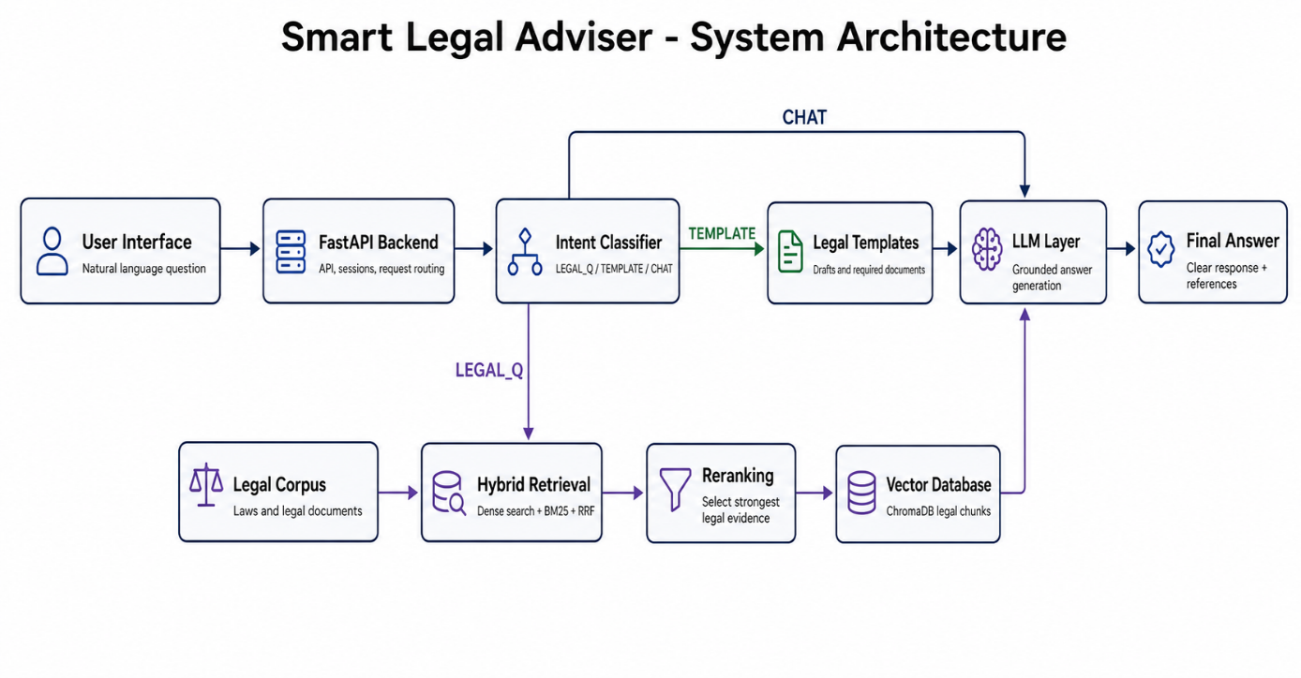
Figure 1 presents the overall architecture of the proposed system. The user submits a natural-language legal question through the user interface. The FastAPI backend receives the request and forwards it to the intent classifier. The intent classifier determines whether the request is a legal question, a template request, or a general chat message. For legal questions, the system uses hybrid retrieval based on semantic search and keyword-based search. The retrieved results are improved using reranking, then the selected legal evidence is passed to the LLM layer to generate the final answer

Data Preparation Pipeline
Before the system can answer user questions, the legal corpus must be prepared. This process is performed offline before user interaction. The purpose of this stage is to transform raw legal documents into clean, structured, and searchable legal records.
The data preparation pipeline includes:
- Collecting legal documents.
- Extracting legal text.
- Cleaning and normalizing the text.
- Segmenting the text into legal articles or templates.
- Extracting metadata.
- Generating embeddings.
- Storing embeddings and metadata in the vector database.
Figure 2:Data Preparation Pipeline
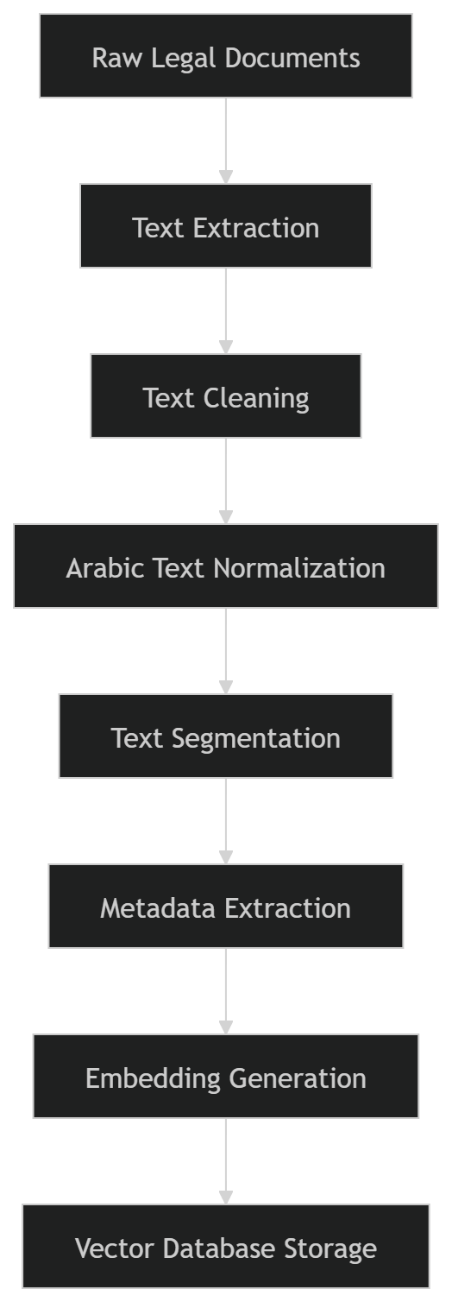

The first stage is raw legal document collection. In this stage, the system collects the Syrian Personal Status Law, Syrian Civil Law, Syrian Penal Code, and legal templates.
The second stage is text extraction. If the legal source is stored as a PDF or another document format, the text must be extracted and converted into machine-readable text.
The third stage is text cleaning. This step removes unnecessary symbols, repeated spaces, page numbers, headers, footers, and formatting noise.
The fourth stage is Arabic text normalization. Arabic letters may appear in different forms. For example, “أ”, “إ”, and “آ” may be normalized to “ا”. This reduces spelling variation and improves retrieval consistency.
The fifth stage is text segmentation. The legal documents are divided into smaller searchable units. In this project, the article is the most suitable unit because each legal article usually contains one legal rule or idea.
The sixth stage is metadata extraction. Metadata includes article number, law name, source, year, category, and topic.
The seventh stage is embedding generation. Each article or template is converted into a numerical vector that represents its meaning.
The final stage is vector database storage. The embeddings are stored with their metadata to support semantic search.

Query and Answer Generation Pipeline
After the legal corpus is prepared and stored, the system becomes ready to answer user questions. This process is performed online whenever the user submits a legal question.
The query pipeline includes:
- Receiving the user question.
- Cleaning and normalizing the question.
- Converting the question into an embedding.
- Searching the vector database.
- Retrieving the most relevant legal passages.
- Reranking the retrieved passages.
- Building a context from the strongest evidence.
- Generating the final answer using a language model.
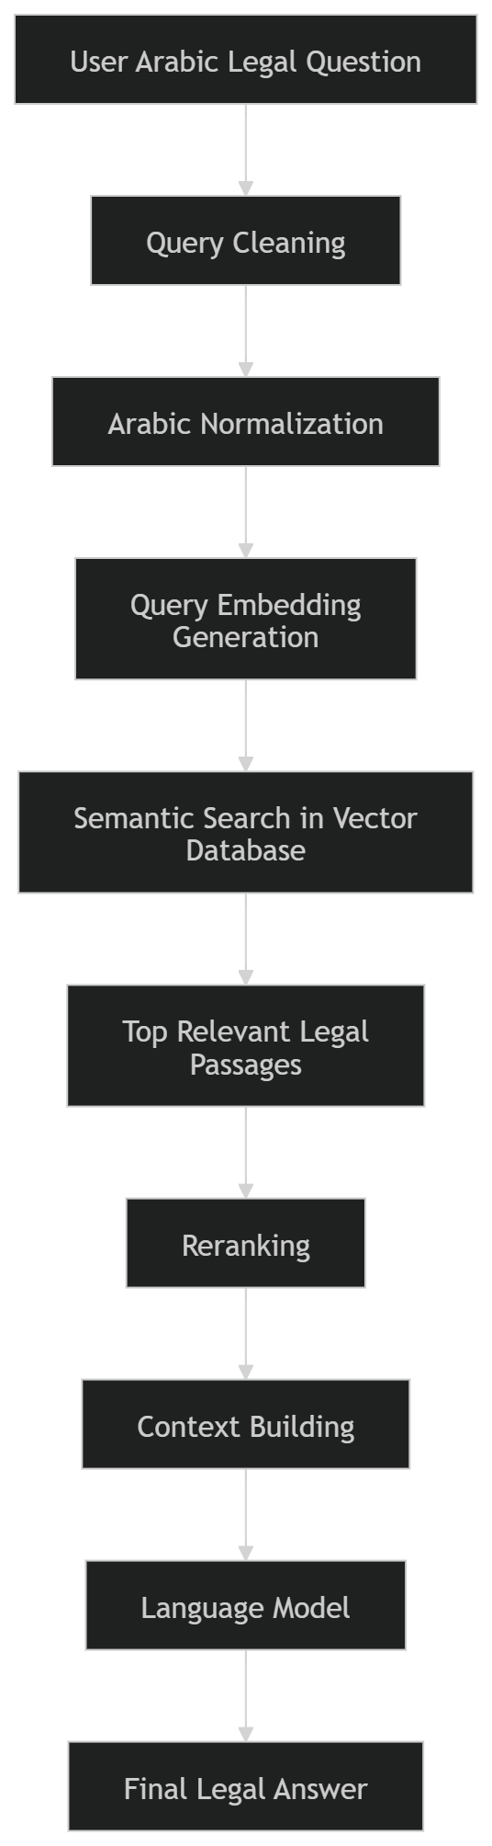
Figure 3:Query and Answer Generation Pipeline

The first stage is receiving the user question. The question may be written in formal Arabic, simple Arabic, or informal Arabic.
The second stage is query cleaning. The system removes unnecessary symbols, repeated spaces, and unsupported characters.
The third stage is Arabic normalization. This step reduces spelling variation and makes the user query more consistent with the indexed legal corpus.
The fourth stage is query embedding generation. The cleaned question is converted into a vector using the same embedding model used for legal texts.
The fifth stage is semantic search. The system compares the query vector with the stored legal vectors and retrieves the most similar legal passages.
The sixth stage is reranking. The retrieved results are reordered to select the strongest legal evidence.
The seventh stage is context building. The selected legal passages are combined into a structured context.
The eighth stage is answer generation. The language model receives the user question and the retrieved context, then generates the final answer.

RAG Pipeline for Legal Questions
The proposed system follows a Retrieval-Augmented Generation pipeline. RAG is suitable for legal applications because legal answers should be based on reliable legal texts. The system does not generate answers directly from the language model alone. Instead, it retrieves relevant legal passages first and then uses them to generate the answer.
Figure 4:RAG Pipeline Used for Answering Legal Questions
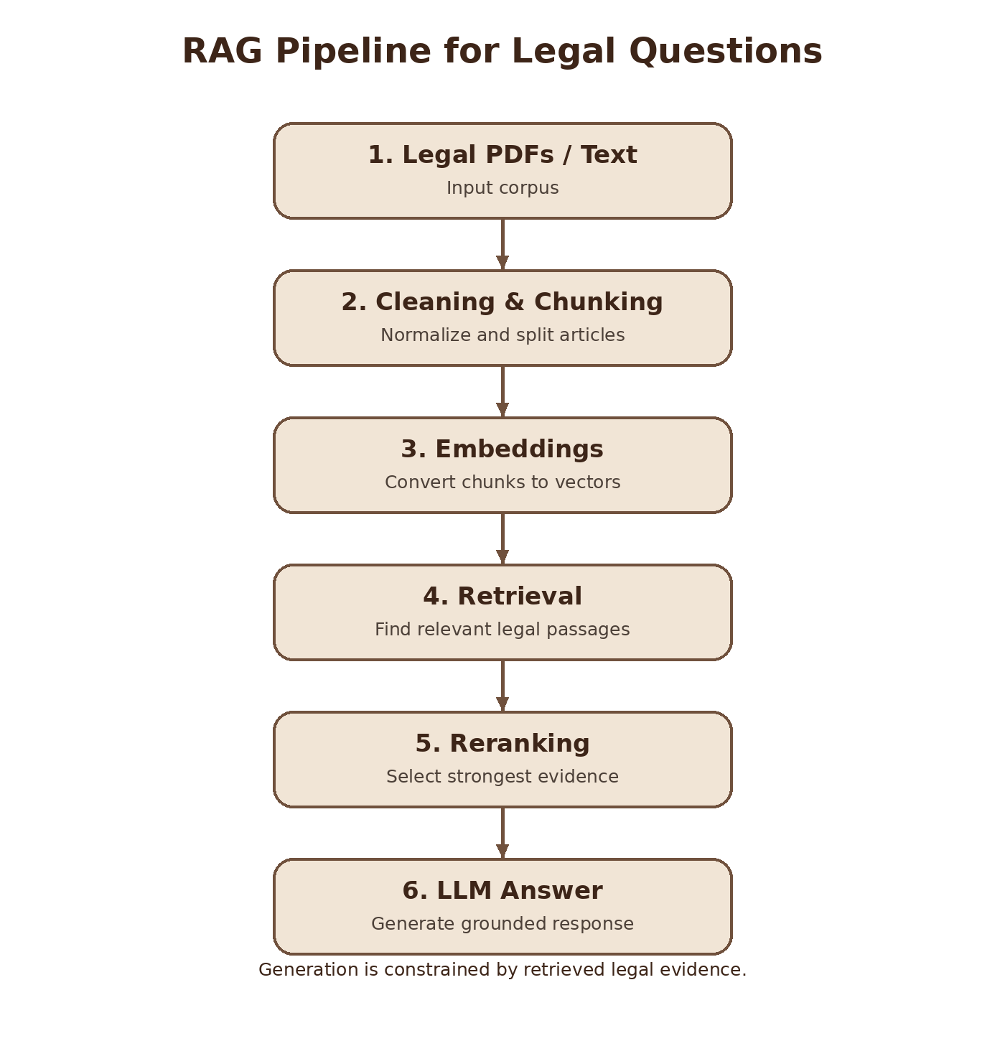
Figure 4 shows the main RAG stages used in the proposed system. The process starts with legal PDFs and text files. These documents are cleaned and divided into chunks. The chunks are converted into embeddings. Then, the system retrieves relevant legal passages, reranks them to select the strongest evidence, and sends the selected context to the language model to generate a grounded legal answer.

Complete RAG Pipeline
The complete RAG pipeline consists of two main stages: the offline indexing stage and the online question-answering stage.
The offline indexing stage prepares the legal corpus before user interaction. The legal files are cleaned, segmented, converted into embeddings, and stored in the vector database.
The online question-answering stage begins when the user asks a question. The question is cleaned, embedded, compared with stored vectors, and used to retrieve relevant legal passages. The retrieved passages are then reranked and used to generate the final answer.
Figure 5:Complete RAG Pipeline of the Proposed System
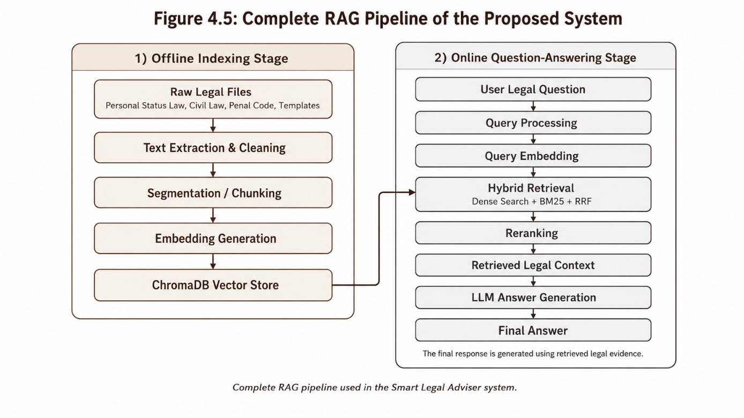

Detailed System Workflow
The following table presents the full workflow of the proposed system.
Step | Stage | Input | Processing | Output
1 | Data Collection | Three legal files and legal templates | Collect legal sources | Raw legal corpus
2 | Text Extraction | PDF / text / JSON files | Extract machine-readable text | Extracted legal text
3 | Text Cleaning | Extracted text | Remove noise, symbols, and repeated spaces | Clean text
4 | Arabic Normalization | Clean text | Normalize letters and remove diacritics | Normalized text
5 | Segmentation | Normalized text | Split text into articles or templates | Legal passages
6 | Metadata Extraction | Legal passages | Extract article number, law name, source, and category | Structured records
7 | Embedding Generation | Structured records | Convert each passage into a vector | Legal embeddings
8 | Vector Storage | Embeddings and metadata | Store in vector database | Searchable legal index
9 | Query Processing | User question | Clean and normalize query | Prepared query
10 | Query Embedding | Prepared query | Convert query into vector | Query embedding
11 | Semantic Retrieval | Query vector and stored vectors | Similarity search | Candidate legal passages
12 | Reranking | Candidate passages | Select strongest legal evidence | Ranked legal passages
13 | Context Building | Retrieved passages | Combine passages into context | Legal context
14 | Answer Generation | User question and legal context | Generate answer using LLM | Final answer
15 | Output Display | Final answer | Present answer to user | User-readable response
Table 9 :Detailed Workflow of the Proposed System

Data Preprocessing
Data preprocessing is a critical stage in the proposed system. The quality of retrieval depends strongly on the quality of the indexed legal texts. If the corpus contains noisy or inconsistent text, the retrieval results may be inaccurate.
Preprocessing Step | Description | Purpose
Noise removal | Removes headers, footers, extra symbols, and repeated characters | Improves text quality
Space correction | Removes repeated spaces and formatting gaps | Produces cleaner text
Arabic normalization | Unifies letter forms such as Alef variations | Reduces spelling variation
Diacritics removal | Removes optional Arabic diacritics | Improves matching consistency
Legal term preservation | Keeps important legal terms unchanged | Maintains legal meaning
Record structuring | Organizes text into article-based records | Supports accurate retrieval
Table 10:Text Preprocessing Steps

Text Segmentation
Text segmentation is the process of dividing the legal corpus into smaller units. In this project, legal articles are used as the main units for indexing. This is suitable because laws are naturally organized into numbered articles.
Article-based segmentation helps improve retrieval because each indexed record contains a focused legal rule. If the whole law were stored as one large document, the system would not be able to retrieve precise results. If the text were divided into very small fragments, the legal context might be lost.

Field | Example
Record ID | law_personal_status_1
Law Name | Syrian Personal Status Law
Article Number | Article 1
Topic | Marriage
Text | Full text of the legal article
Metadata | Law year, source, category
Table 11:Example of a Structured Legal Article

Embedding Generation
After segmentation, each legal article or template is converted into an embedding. An embedding is a numerical vector that represents the meaning of the text.
The purpose of embeddings is to support semantic search. This means that the system can retrieve legal texts based on meaning, even when the user does not use the exact words found in the law.
For example, the user may ask:
"ما هي حقوق الزوجة بعد الطلاق؟"
The law may discuss related concepts such as alimony, waiting period, divorce effects, or financial rights. Embeddings help the system connect the user question with related legal texts.

Figure 6 :Text-to-Embedding Process
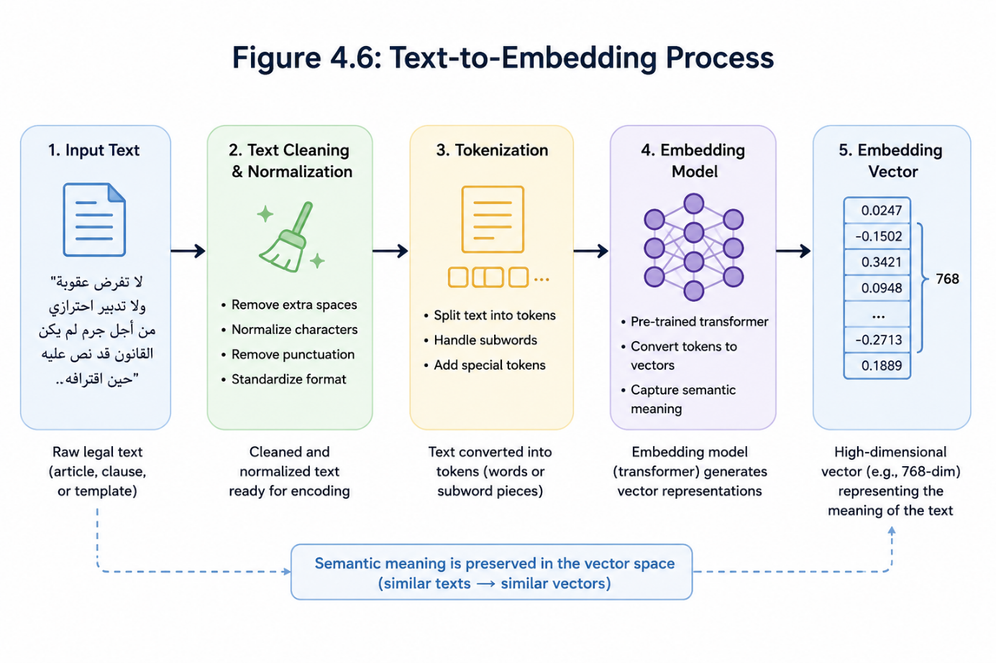

Vector Database Storage
The generated embeddings are stored in a vector database. A vector database allows the system to perform similarity search between the user question and the stored legal texts.
Each record in the vector database contains the embedding vector and the related legal metadata. This allows the system to retrieve not only the vector, but also the original legal article and its source information.
Stored Item | Description
Vector ID | Unique identifier for the stored legal passage
Embedding Vector | Numerical representation of the legal text
Original Text | The legal article or template text
Law Name | Name of the legal source
Article Number | Article number if available
Category | Legal topic or template category
Metadata | Source, year, type, and other useful information
Table 12:Vector Database Record Structure

Semantic Retrieval and Hybrid Retrieval
Semantic retrieval searches for legal texts that are close in meaning to the user question. The query embedding is compared with the stored legal embeddings, and the most similar records are retrieved.
However, the proposed system also uses hybrid retrieval. Hybrid retrieval combines semantic search with keyword-based search. This improves retrieval because some legal questions require exact legal terms, while others require semantic understanding.
The hybrid retrieval approach includes:
- Dense semantic search.
- BM25 keyword search.
- Reciprocal Rank Fusion.
- Reranking.
Component | Description | Role in the System
Dense Search | Uses embeddings to find semantically similar passages | Retrieves results based on meaning
BM25 Search | Uses keyword-based ranking | Retrieves results based on exact legal terms
Reciprocal Rank Fusion | Combines ranked lists from dense and keyword-based retrieval | Produces a stronger combined ranking
Reranking | Reorders candidate passages by relevance | Selects the strongest legal evidence
Table 13:Hybrid Retrieval Components

Answer Generation
After retrieval and reranking, the selected legal passages are sent to the language model. The language model uses the retrieved passages as context and generates the final answer.
The answer generation stage must be carefully controlled because the legal domain requires accuracy. The system should not invent legal rules or article numbers. The answer should be based on the retrieved context whenever possible.
The generated answer should be:
- Clear.
- Direct.
- Based on retrieved legal text.
- Written in understandable language.
- Limited to the available legal corpus.
- Honest when the system does not have enough information.
Figure 7 :Answer Generation Using Retrieved Context
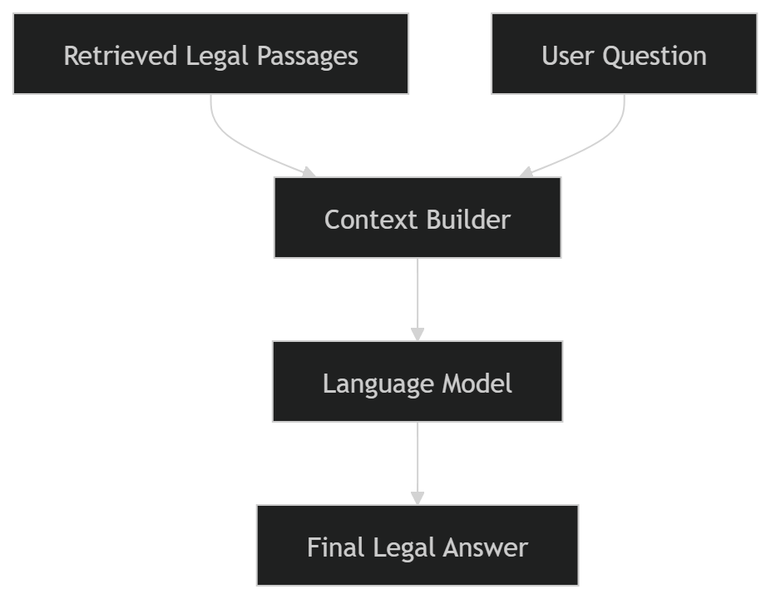

Tools and Technologies Used
The proposed system can be implemented using several tools and technologies. These tools support backend development, data processing, embedding generation, vector storage, retrieval, reranking, and answer generation.
Tool / Technology | Purpose in the System
Python | Main programming language
FastAPI | Backend API development
ChromaDB | Vector database storage and retrieval
LlamaIndex | RAG pipeline support and vector-store integration
Sentence Transformers | Embedding model support
Torch | Deep learning model execution
OpenAI / OpenRouter API | Language-model-based answer generation
Cohere | Reranking and retrieval improvement
JSON | Structured storage of processed legal data
Web Interface | Allows the user to submit questions and view answers
Table 14 :Tools and Technologies Used

Models Used in the Proposed System
The proposed system uses several models for embedding generation, reranking, query processing, answer generation, and evaluation. These models are selected to support Arabic semantic retrieval and grounded answer generation.
The embedding model used in the system is intfloat/multilingual-e5-large. This model converts both legal passages and user queries into numerical vectors. The embedding implementation uses the E5 convention, where search queries are prefixed with “query:” and legal documents are prefixed with “passage:”. The embedding dimension is 1024.
The reranking stage uses a multilingual reranking model through the Cohere API. The reranker receives the user query and the candidate retrieved passages, then reorders the passages according to relevance.
The answer generation and query rewriting stages use LLM models configured through OpenRouter. The query rewriting module uses the configured fast model to rewrite colloquial or mixed-language Arabic questions into formal legal Arabic questions suitable for retrieval.
Model / Service | Type | Used For | Notes
intfloat/multilingual-e5-large | Embedding model | Converts Arabic legal texts and user queries into vectors | Local multilingual E5 model, 1024-dimensional embeddings
rerank-multilingual-v3.0 | Reranker model | Reorders retrieved candidate legal passages | Used through Cohere rerank API
meta-llama/llama-3.3-70b-instruct | Judge LLM | Evaluates generated answers | Used in LLM-as-a-Judge evaluation
OpenRouter LLM models  (openai/gpt-4o-mini) | Generation / classification LLM | Query rewriting, intent classification, answer generation | Configured through environment variables
Table 15:Models Used in the Proposed System

Chapter Summary
This chapter presented the research methodology of the proposed Smart Legal Adviser system. It began by describing the datasets used in the project, including the three main law files: Syrian Personal Status Law, Syrian Civil Law, and Syrian Penal Code. It also described the legal templates dataset used to support procedural legal tasks.
The chapter explained the full system methodology, including data collection, text extraction, preprocessing, segmentation, metadata extraction, embedding generation, vector database storage, semantic retrieval, hybrid retrieval, reranking, context building, and answer generation.
Several figures and tables were included to clarify the methodology. The figures illustrated the system architecture, data preparation pipeline, query pipeline, RAG pipeline, text-to-embedding process, and answer generation process. The tables described the datasets, dataset structure, workflow, preprocessing steps, vector database structure, hybrid retrieval components, and tools used.
The methodology is suitable for the proposed legal adviser because it allows the system to retrieve legal information based on meaning rather than exact keywords. It also grounds the generated answer in retrieved legal texts, which is essential in the legal domain.
The next chapter presents the results of the proposed system, including the evaluation methods, system outputs, and comparison with related work.

Chapter 5

Results and Evaluation

Introduction
This chapter presents the results and evaluation of the proposed Smart Legal Adviser system. The purpose of this chapter is to evaluate the implemented system using the evaluation files and result files developed in the project.
The evaluation focuses on four main aspects:
- Query cleaning and rewriting.
- Legal text retrieval performance.
- Generated answer quality.
- Intent classification accuracy.
The system was evaluated using verified legal questions and expected gold legal article keys. The evaluation files define the test questions, retrieval metrics, LLM-based answer evaluation, out-of-scope rejection, and intent classification accuracy. The final result files summarize the system performance across retrieval, answer quality, and intent classification.
The evaluation summary shows that the system achieved an overall answer quality score of 8.8/10, production retrieval performance of 95.8% at Recall@6, intent classification accuracy of 80.0%, and out-of-scope rejection of 100%.

Evaluation Dataset
The evaluation dataset is defined in eval_questions.py. This file contains verified single-topic legal questions. Each legal question is linked to:
- Expected gold legal article keys.
- Legal topic.
- Difficulty level.
The evaluated legal topics include custody, divorce, maintenance, marriage, lineage, and inheritance. The file also contains out-of-scope questions used to test whether the system refuses unsupported queries.

Category | Description | Example Topic
Custody | Questions related to child custody and visitation | حضانة
Divorce | Questions related to divorce and separation | طلاق
Maintenance | Questions related to alimony and financial support | نفقة
Marriage | Questions related to marriage conditions and validity | زواج
Lineage | Questions related to proving lineage | نسب
Inheritance | Questions related to wills and inheritance | ميراث
Out-of-scope | Questions outside the supported legal corpus | Mathematics, exchange rate, programming
Table 16 :Evaluation Question Categories
The result summary states that the retrieval evaluation used 24 legal questions and 5 out-of-scope questions.

Query Cleaning and Rewriting
Before retrieval, the system applies Arabic query cleaning and, when needed, query rewriting. These steps improve the consistency between the user’s question and the indexed legal corpus.
The query processing code includes three main functions:
- clean_text
- should_rewrite_query
- rewrite_query
These functions are implemented in query_processor.py

Query Cleaning Function
The function clean_text(text: str) prepares the user query before retrieval.
It performs the following operations:
- Removes Arabic diacritics.
- Removes tatweel characters.
- Normalizes different Alef forms: أ, إ, آ → ا.
- Converts ة to ه.
- Converts ى to ي.
- Removes unsupported symbols.
- Reduces repeated spaces.
This step helps reduce spelling variation in Arabic and improves the retrieval process.
Operation | Example | Purpose
Diacritics removal | مُحكمة → محكمة | Reduces text variation
Alef normalization | أ / إ / آ → ا | Standardizes Arabic spelling
Letter normalization | ة → ه, ى → ي | Improves matching consistency
Symbol removal | Removes unsupported characters | Reduces noise
Space normalization | Multiple spaces → one space | Produces clean query text
Table 17:Query Cleaning Operations

Query Rewriting Decision Function
The function should_rewrite_query(query: str) decides whether the query should be rewritten.
The system does not rewrite every question. Short and clear legal questions are kept unchanged. Questions that mention a specific legal article are also preserved to avoid changing the article reference.
The function triggers rewriting when the query contains colloquial markers such as:
- بدي
- شو
- ليش
- وين
- كيف بدي
- ممكن
- لو سمحت
It may also trigger rewriting when the query is long and needs to be converted into a concise legal question.

Case | System Behavior
Short clear legal query | No rewriting
Query cites a legal article | No rewriting
Colloquial query | Rewrite into formal legal Arabic
Very long query | Rewrite into concise legal form
Empty query | No rewriting
Table 18 :Query Rewriting Decision Logic

Query Rewriting Function
The function rewrite_query(query: str) rewrites colloquial or mixed-language legal questions into concise formal Arabic legal questions suitable for searching Syrian statutory law.
The rewriting prompt instructs the model to preserve procedural terms, including:
- تبليغ → إجراءات التبليغ القضائي
- استئناف → إجراءات الاستئناف القضائي
- اختصاص → الاختصاص القضائي للمحكمة
- تنفيذ → تنفيذ الأحكام القضائية
The prompt also prevents the model from inventing article numbers that were not mentioned by the user.

User Query Style | Example | Expected Rewritten Meaning
Colloquial Arabic | شو شروط الحضانة؟ | ما هي شروط الحضانة في القانون السوري؟
Procedural query | شو إجراءات تبليغ المدعى عليه؟ | ما هي إجراءات التبليغ القضائي؟
Long query | بدي أعرف إذا فيني أرفع دعوى نفقة… | ما شروط دعوى النفقة؟
Article-based query | اشرح المادة 137 | Kept unchanged
Table 19 :Query Rewriting Examples

Retrieval Evaluation
The retrieval evaluation measures whether the system can retrieve the correct legal articles for a given legal question.
The file eval_retrieval.py evaluates the retrieval system using Recall@K. The K values used in the file are:
K_VALUES = [1, 3, 6, 10]
Therefore, the retrieval system is evaluated using:
- Recall@1
- Recall@3
- Recall@6
- Recall@10
The file also reports average retrieval time, per-topic Recall@6, ablation results, full production pipeline results, and out-of-scope rejection.

Recall@K Metric
Recall@K measures whether at least one correct legal article appears within the top K retrieved results.
Equation 1:Recall@K
$$Recall@K=\frac{Number of questions with at least one correct article in Top-K}{Total number of evaluated legal questions}$$
A retrieved result is considered correct if its key matches one of the gold article keys defined for the question in the evaluation dataset.
For example, if a question has four expected legal articles and the system retrieves one of them within the top six results, the question is counted as successful for Recall@6.

Retrieval Evaluation Results
The production retrieval pipeline achieved:
- Recall@1: 54.2%
- Recall@3: 83.3%
- Recall@6: 95.8%
- Recall@10: 100.0%
- Average retrieval time: 9295.1 ms
These results are reported in retrieval_eval2.json.

Method | Recall@1 | Recall@3 | Recall@6 | Recall@10 | Average Time
Dense only | 83.3% | 87.5% | 95.8% | 100.0% | 702.0 ms
BM25 only | 37.5% | 45.8% | 45.8% | 66.7% | 15.6 ms
Dense×2 + BM25 + RRF | 54.2% | 79.2% | 100.0% | 100.0% | 1258.6 ms
Full Pipeline | 54.2% | 83.3% | 95.8% | 100.0% | 9295.1 ms
Table 20:Retrieval Evaluation Results
The results show that dense retrieval performed strongly for semantic legal search, while BM25 alone had lower recall. Combining semantic retrieval with keyword-based retrieval improved recall in the intermediate ranks. The full production pipeline achieved high retrieval reliability, especially at Recall@6 and Recall@10.

Per-Topic Recall@6
The retrieval evaluation also reports Recall@6 for each legal topic. This helps identify how retrieval performance changes across different legal domains.
Equation 2 :Per-Topic Recall@6
$$Per-Topic Recall@6=\frac{Number of successful Recall@6 cases in a topic}{Total questions in the same topic}$$
uction pipeline achieved perfect Recall@6 in custody, divorce, marriage, lineage, and inheritance. Maintenance achieved 75.0%.
Topic | Hits | Total Questions | Recall@6
Custody | 4 | 4 | 100.0%
Divorce / Motion | 5 | 5 | 100.0%
Maintenance | 3 | 4 | 75.0%
Marriage | 4 | 4 | 100.0%
Lineage | 3 | 3 | 100.0%
Inheritance | 4 | 4 | 100.0%
Table 21:Per-Topic Recall@6 Results
The lower score in maintenance indicates that some financial-support questions may require better query rewriting, additional legal context, or improved retrieval tuning.

Out-of-Scope Rejection Evaluation
The system was also evaluated on out-of-scope questions. These are questions outside the supported legal corpus.
The out-of-scope rejection rate is calculated as follows:
Equation 3 :Out-of-Scope Rejection Rate
$$Out-of-Scope Rejection Rate=\frac{Number of rejected out-of-scope questions}{Total out-of-scope questions}×100$$
The retrieval evaluation result shows that the system rejected 5 out of 5 out-of-scope questions, achieving a rejection rate of 100.0%
Total Out-of-Scope Questions | Rejected Questions | Rejection Rate
5 | 5 | 100.0%
Table 22 :Out-of-Scope Rejection Results
The LLM-as-a-Judge evaluation also included an out-of-scope refusal check and reported 3 out of 3 rejected questions, with a rejection rate of 100.0%

LLM-as-a-Judge Evaluation
The generated answers were evaluated using an LLM-as-a-Judge method. In this method, a judge model evaluates the system’s answer based on the retrieved legal context.
The file eval_llm_judge.py sends the following information to the judge model:
- The legal question.
- The generated answer.
- The retrieved legal context.
The judge scores the answer according to four criteria:
- Accuracy.
- Completeness.
- No hallucination.
- Clarity.
Each criterion is scored from 0 to 10.
The result file llm_judge_eval.json shows that the judge model used was:
meta-llama/llama-3.3-70b-instruct
The number of evaluated legal questions was 24.

LLM-as-a-Judge Metrics
Equation 4 :Answer Average Score
$Answer Average =$(Accuracy + Completeness + No Hallucination + Clarity) / 4
Equation 5:Overall Average
$$Overall Average =\frac{Sum of all answer average scores}{Number of evaluated answers}$$
Criterion | Average Score
Accuracy | 8.5 / 10
Completeness | 8.7 / 10
No Hallucination | 9.5 / 10
Clarity | 8.5 / 10
Overall Average | 8.8 / 10

Table 23 : LLM-as-a-Judge Evaluation Results

The result shows that the system achieved the highest score in No Hallucination, with 9.5/10. This indicates that the generated answers were strongly grounded in the retrieved legal context and rarely invented unsupported legal information.

Sample LLM Judge Results
The LLM judge result file includes detailed scores for each evaluated question. Some answers achieved high scores, such as:
- “متى تبطل الوصية؟” → 10.0 / 10
- “هل يرث غير المسلم من المسلم؟” → 10.0 / 10
- “ما هي شروط الحضانة في القانون السوري؟” → 9.5 / 10
- “ما حكم الطلاق الرجعي؟” → 9.5 / 10
Some questions received lower scores due to incomplete coverage or unclear wording, such as:
- “ما حكم الزواج بدون ولي؟” → 7.5 / 10
- “ما شروط الطلاق الخلعي؟” → 7.8 / 10
These details are reported in llm_judge_eval.json file.
Question | Accuracy | Completeness | No Hallucination | Clarity | Average
ما هي شروط الحضانة في القانون السوري؟ | 9 | 10 | 10 | 9 | 9.5
ما شروط الطلاق الخلعي؟ | 8 | 6 | 9 | 8 | 7.8
متى تبطل الوصية؟ | 10 | 10 | 10 | 10 | 10.0
هل يرث غير المسلم من المسلم؟ | 10 | 10 | 10 | 10 | 10.0
ما حكم الزواج بدون ولي؟ | 8 | 6 | 9 | 7 | 7.5
Table 24:Sample Answer Quality Results

Intent Classification Evaluation
The system also evaluates intent classification. Intent classification determines the processing path for the user query.
The possible intents include:
Intent | Meaning
LEGAL_Q | A legal question requiring retrieval from legal articles
TEMPLATE | A request for a legal template
ATTACHMENT | A request for required documents
CHAT | A general message
The file eval_intent.py evaluates the classifier using a test suite and reports overall accuracy, rules-layer resolution rate, LLM-layer resolution count, accuracy per difficulty level, and error analysis.
The result file intent_eval2.json reports:
- Total test cases: 40
- Correct classifications: 32
- Overall accuracy: 80.0%
- Rules-resolved queries: 4
- LLM-resolved queries: 36
- Easy accuracy: 77.8%
- Medium accuracy: 88.2%
- Hard accuracy: 71.4%

Intent Classification Metrics
Equation 6 :Intent Classification Accuracy
$$Intent Classification Accuracy =\frac{Number of correctly classified queries}{Total number of test queries}×100$$
Equation 7:Rules-Layer Resolution Rate
$$Rules-Layer Resolution Rate =\frac{Number of queries resolved by rules layer}{Total number of test queries}×100$$

Equation 8: LLM-Layer Resolution Rate
$$LLM-Layer Resolution Rate =\frac{Number of queries resolved by LLM layer}{Total number of test queries}×100$$

Metric | Result
Total Test Cases | 40
Correct Classifications | 32
Overall Accuracy | 80.0%
Rules-Layer Resolved Queries | 4
Rules-Layer Rate | 10.0%
LLM-Layer Resolved Queries | 36
LLM-Layer Rate | 90.0%
Table 25 :Intent Classification Results
Difficulty | Correct | Total | Accuracy
Easy | 7 | 9 | 77.8%
Medium | 15 | 17 | 88.2%
Hard | 10 | 14 | 71.4%
Table 26: Intent Accuracy by Difficulty
The highest classification performance was achieved on medium-difficulty cases. Hard cases had the lowest score because they often include mixed intentions, such as requesting both a legal template and legal explanation in the same query.

Intent Classification Error Analysis
The intent evaluation file includes eight classification errors. Some errors occurred when the query had multiple possible meanings, such as a template request combined with an attachment request or a legal explanation request.
Examples include:
- “بدي دعوى نفقة زوجة” expected TEMPLATE, but the system returned TEMPLATE and ATTACHMENT.
- “بدي أرفع دعوى إسقاط حضانة” expected TEMPLATE, but the system returned TEMPLATE and ATTACHMENT.
- “ما هي وثائق دعوى الطلاق الخلعي؟” expected ATTACHMENT, but the system returned ATTACHMENT and LEGAL_Q.
These errors show that many misclassifications were not completely wrong, but rather over-classifications where the system detected more than one intent.
Query | Expected Intent | Actual Intent | Difficulty
بدي دعوى نفقة زوجة | TEMPLATE | TEMPLATE + ATTACHMENT | Easy
بدي أرفع دعوى إسقاط حضانة | TEMPLATE | TEMPLATE + ATTACHMENT | Hard
لوين بروح إذا بدي أرفع دعوى طلاق؟ | TEMPLATE | LEGAL_Q + TEMPLATE | Hard
ما هي وثائق دعوى الطلاق الخلعي؟ | ATTACHMENT | ATTACHMENT + LEGAL_Q | Easy
Table 27:Examples of Intent Classification Errors

System Interface Results
In addition to numerical evaluation, screenshots of the user interface should be included to demonstrate the implemented system.
The interface screenshots are not numerical evaluation metrics. They are included to show system usability and practical behavior.

Figure 8 :Main User Interface
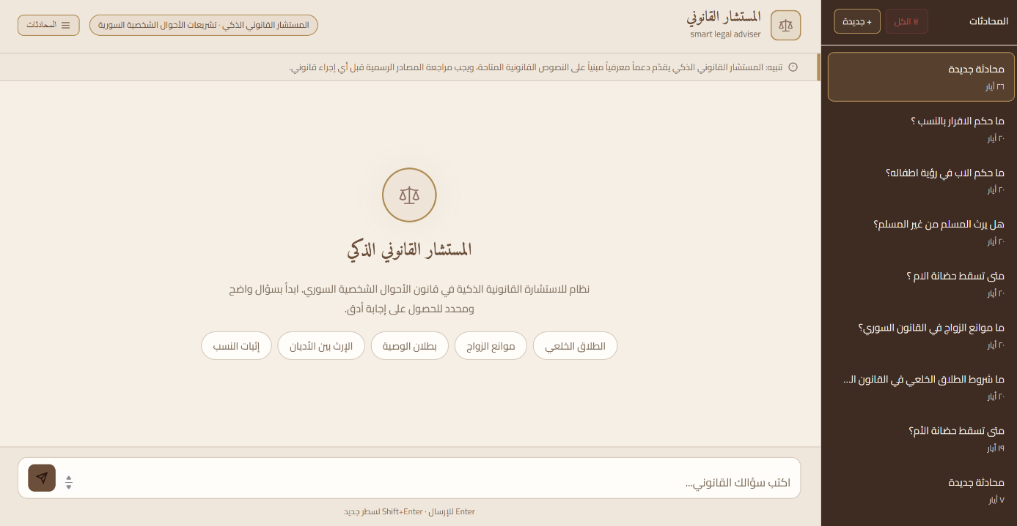
Figure 8 shows the main user interface of the system. The user can enter an Arabic legal question through the input field, while the system displays the generated answer in the conversation area.
Figure 9 :Legal Question Answering Example
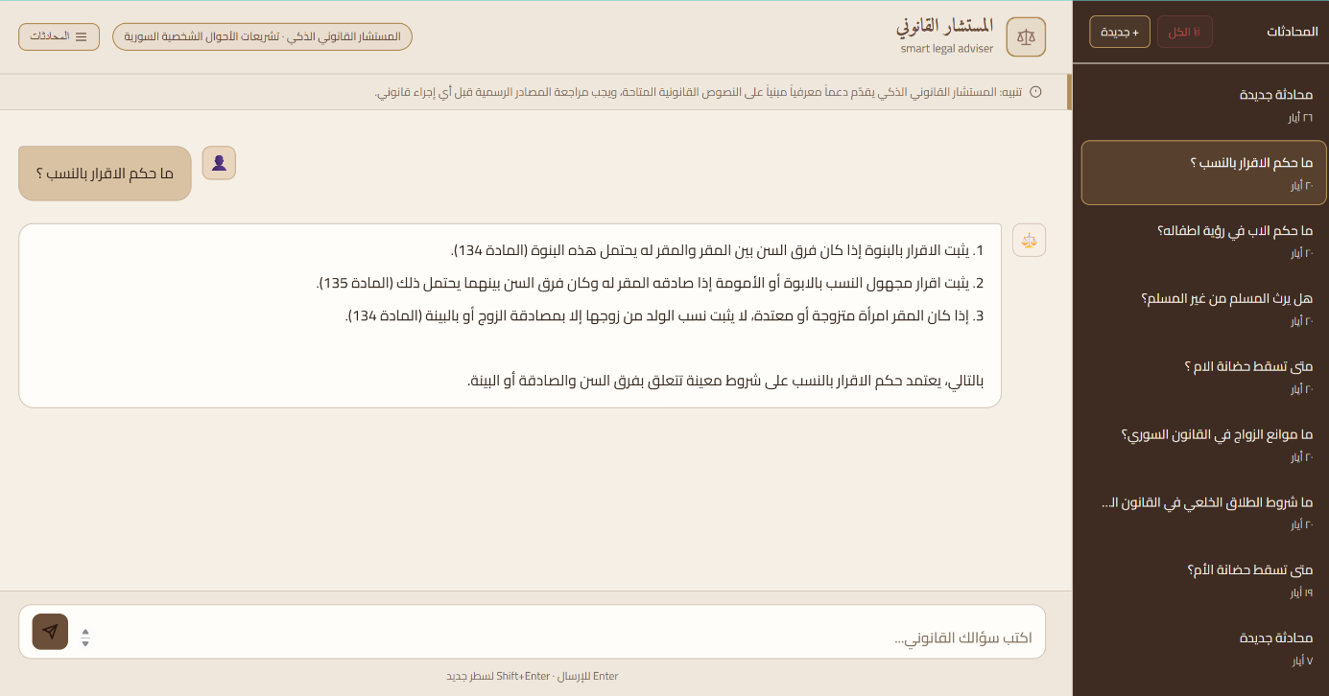
Figure 9 shows an example of a legal question submitted by the user. The system processes the question, retrieves relevant legal articles, and generates an answer based on the retrieved context.
Figure 10: user question in slang arabic


Overall Evaluation Summary
The final evaluation summary file combines the main results from retrieval, answer quality, and intent classification.

Evaluation Aspect | Result
Answer Quality Overall Average | 8.8 / 10
Retrieval Production Recall@6 | 95.8%
Retrieval Production Recall@10 | 100.0%
Intent Classification Accuracy | 80.0%
Out-of-Scope Rejection | 100.0%
Table 28 :Overall Evaluation Summary
The summary confirms that the system performs well in legal answer generation and retrieval. The strongest result is the low hallucination rate, reflected by a No Hallucination score of 9.5/10. The retrieval system also achieved high reliability at Recall@6 and Recall@10. Intent classification achieved acceptable performance, but the error analysis shows that mixed-intent questions remain a challenge.

Discussion of Results
The evaluation results show that the proposed Smart Legal Adviser system achieved its main functional goals.
The retrieval evaluation indicates that the system can retrieve relevant legal articles with high reliability. The production pipeline achieved 95.8% Recall@6 and 100.0% Recall@10, which means that the correct legal article usually appears within the top retrieved results.
The LLM-as-a-Judge evaluation shows that the generated answers are generally accurate, complete, clear, and well-grounded in the retrieved context. The system achieved an overall score of 8.8/10, with the highest score in No Hallucination, reaching 9.5/10.
The out-of-scope evaluation shows that the system successfully refused unsupported questions. This is important for a legal assistant because it should not generate answers outside the available legal corpus.
The intent classification evaluation achieved 80.0% accuracy. Most classification errors occurred in mixed or ambiguous queries. This suggests that future improvements should focus on better handling of multi-intent questions and colloquial Arabic expressions.

Chapter Summary
This chapter presented the results and evaluation of the proposed Smart Legal Adviser system. It described the evaluation dataset, query cleaning and rewriting functions, retrieval evaluation, out-of-scope rejection, LLM-as-a-Judge answer evaluation, intent classification evaluation, and system interface screenshots.
The retrieval evaluation used Recall@1, Recall@3, Recall@6, and Recall@10. The production pipeline achieved 95.8% Recall@6 and 100.0% Recall@10. The LLM-as-a-Judge evaluation achieved an overall answer quality score of 8.8/10. The system also achieved 100.0% out-of-scope rejection and 80.0% intent classification accuracy.
The results indicate that the system is effective for retrieving Syrian personal status legal articles and generating grounded legal answers. However, the intent classification errors show that mixed-intent and colloquial legal questions still require further improvement.
The next chapter presents the conclusion, challenges, and future work.

Chapter 6

Conclusion and Future Work

6.1 Introduction
This chapter presents the conclusion of the proposed Smart Legal Adviser system. It summarizes the main work completed in the project, discusses the achieved results, explains the main challenges faced during development and evaluation, and proposes future improvements.
The project aimed to build an intelligent legal assistant that can process Arabic legal questions, retrieve relevant Syrian legal articles, and generate grounded answers based on the retrieved legal context. The system was designed using a Retrieval-Augmented Generation approach, supported by Arabic query cleaning, query rewriting, hybrid retrieval, reranking, vector database storage, and LLM-based answer generation.
The final evaluation showed that the system achieved strong results in legal retrieval and answer generation. The production retrieval pipeline reached 95.8% Recall@6 and 100.0% Recall@10, while the LLM-as-a-Judge evaluation reported an overall answer quality score of 8.8/10. The system also achieved 100.0% out-of-scope rejection, showing that it can refuse unsupported questions instead of generating unreliable answers.

6.2 General Conclusion
The proposed Smart Legal Adviser system successfully demonstrates how Artificial Intelligence and Natural Language Processing can be applied to Arabic legal texts. The system provides a practical method for helping users access legal information by asking questions in natural Arabic language.
Instead of depending only on keyword-based search, the system uses semantic retrieval and embeddings to understand the meaning of the user’s question. This allows the system to retrieve legal articles even when the user does not use the exact wording found in the law. The retrieved legal passages are then passed to a language model, which generates a clear answer grounded in the legal corpus.
The system was developed using three main Syrian legal sources: the Syrian Personal Status Law, the Syrian Civil Law, and the Syrian Penal Code. In addition, legal templates were used to support procedural requests and document-related tasks. The legal texts were cleaned, structured, converted into embeddings, and stored in a vector database to support semantic retrieval.
The project confirms that Retrieval-Augmented Generation is suitable for legal applications because it reduces the risk of unsupported answers. The answer is not generated only from the language model’s general knowledge. Instead, it is generated based on retrieved legal evidence.

6.3 Main Achievements
The main achievements of this project can be summarized as follows:

Building an Arabic Legal Question-Answering System
The project developed a legal assistant capable of receiving Arabic legal questions and generating answers based on retrieved Syrian legal texts. This supports the main objective of improving access to legal information.

Preparing a Syrian Legal Corpus
The system used structured legal data from Syrian legal sources. These sources were prepared and converted into searchable records, allowing the system to retrieve legal articles according to user questions.

Applying Query Cleaning and Rewriting
The system includes Arabic query processing functions. These functions clean the user query, normalize Arabic characters, remove unsupported symbols, and rewrite colloquial or mixed-language questions into formal Arabic legal questions when needed. The query rewriting function also preserves important procedural terms and prevents invented article references.

Implementing Semantic and Hybrid Retrieval
The system uses semantic retrieval based on embeddings, as well as keyword-based retrieval. These methods help improve legal article retrieval by combining meaning-based search with exact-term search.

Using Reranking to Improve Evidence Selection
After retrieving candidate legal passages, the system uses a reranking stage to reorder the results and select stronger legal evidence. This improves the quality of the context passed to the language model.

Evaluating the System with Verified Questions
The system was evaluated using verified legal questions linked to gold legal article keys. The evaluation covered retrieval performance, answer quality, out-of-scope rejection, and intent classification.

Achieving Strong Evaluation Results
The final result summary shows the following:
Evaluation Aspect | Result
Answer Quality Overall Average | 8.8 / 10
Production Retrieval Recall@6 | 95.8%
Production Retrieval Recall@10 | 100.0%
Intent Classification Accuracy | 80.0%
Out-of-Scope Rejection | 100.0%
Table 29 :The final result summary
These results show that the system is effective in retrieving relevant legal texts and generating grounded legal answers

Discussion of Results
The evaluation results show that the proposed system performs well in legal retrieval and answer generation.
The retrieval evaluation shows that the correct legal article usually appears within the top retrieved results. The production pipeline achieved 95.8% Recall@6 and 100.0% Recall@10, which indicates that the system can reliably retrieve relevant legal articles for most evaluated questions.
The LLM-as-a-Judge evaluation shows that the generated answers are generally accurate, complete, clear, and grounded in the retrieved legal context. The system achieved an overall score of 8.8/10, with the highest individual score in No Hallucination, reaching 9.5/10. This is important because legal assistants must avoid inventing unsupported legal rules or article numbers.
The out-of-scope rejection result was also strong. The system rejected all unsupported questions in the retrieval evaluation and the LLM-as-a-Judge evaluation. This means that the system can identify when a question is outside the available corpus and avoid producing misleading answers.
However, the intent classification evaluation achieved 80.0% accuracy, which shows that this part of the system still needs improvement. Most errors appeared in mixed-intent or ambiguous questions, where the user may request a template, attachments, and legal explanation in the same sentence.

Challenges
Several challenges were observed during the project.

Arabic Language Complexity
Arabic language processing is difficult because Arabic words can appear in different forms. The same word may have prefixes, suffixes, or spelling variations. This required query cleaning and normalization before retrieval.

Legal Language Complexity
Legal texts are formal and precise. A single article may contain conditions, exceptions, or references to other legal rules. This makes legal question answering more difficult than general question answering.

Colloquial User Questions
Users may ask questions in colloquial Arabic instead of formal legal Arabic. This creates a gap between user language and legal text. The system addresses this using query rewriting, but more improvement is still needed.

Mixed-Intent Questions
Some user questions include more than one request, such as asking for a legal template and a legal explanation at the same time. This affected intent classification performance and caused some over-classification errors.

Retrieval Completeness
Although retrieval performance was strong, some topics still had lower scores. For example, maintenance questions achieved 75.0% Recall@6, which indicates that some financial-support questions may require better query rewriting or retrieval tuning.

Legal Responsibility
The system provides legal assistance and information retrieval, but it cannot replace a licensed lawyer. Legal advice may require case-specific facts, judicial interpretation, and professional responsibility.

Limitations
The project has several limitations.
First, the system depends on the available legal corpus. If a law, article, amendment, or procedure is missing from the corpus, the system may not be able to answer correctly.
Second, the system was evaluated on a limited set of verified questions. Although the results are strong, a larger evaluation set would provide a more complete measurement of performance.
Third, the system currently focuses mainly on Syrian legal texts and selected legal templates. It does not cover every possible Syrian legal domain.
Fourth, the generated answer depends on the retrieved context. If retrieval misses an important article, the generated answer may be incomplete.
Fifth, the intent classifier still needs improvement, especially for mixed-intent and colloquial questions.

Future Work
Several future improvements can be added to the system.

Expanding the Legal Corpus
The system can be improved by adding more Syrian laws, amendments, court procedures, and legal references. This would increase the coverage of the assistant and allow it to answer a wider range of legal questions.

Improving Intent Classification
The intent classifier should be improved to better handle mixed-intent questions. Future versions can classify each part of a user request separately instead of assigning one or more broad labels to the whole query.

Enhancing Query Rewriting
The query rewriting module can be improved to handle more colloquial Arabic expressions and more legal domains. This would help users who do not know formal legal terminology.

Adding Citation Display in Answers
Future versions should display article numbers and law names clearly with each answer. This would make the answer more transparent and easier to verify.

Adding User Feedback
A feedback system can be added so users can mark answers as useful, incomplete, or incorrect. This feedback can help improve retrieval and answer generation over time.

Improving Legal Template Support
The legal template module can be expanded to support more forms, automatic field filling, and document export to Word or PDF.

Supporting More Evaluation Cases
The evaluation dataset can be expanded with more questions, more topics, and different difficulty levels. This would provide a stronger measurement of system performance.

Adding Multilingual Support
The system can be extended to support English legal questions or bilingual Arabic-English legal explanation. This may help law students, researchers, and international users.

Deployment and Security Improvements
Future versions can improve deployment, authentication, user data privacy, logging, and secure session management. This is important if the system is used in a real legal environment.

Final Conclusion
This project presented a Smart Legal Adviser system for Arabic legal question answering. The system combines Arabic text preprocessing, query rewriting, embeddings, vector database retrieval, hybrid search, reranking, and language-model-based answer generation.
The evaluation results show that the system achieved strong performance in retrieval and answer quality. The production retrieval pipeline reached 95.8% Recall@6 and 100.0% Recall@10. The generated answers achieved an overall LLM-as-a-Judge score of 8.8/10, with 9.5/10 in no hallucination. The system also achieved 100.0% out-of-scope rejection, showing that it can avoid answering unsupported questions.
The project demonstrates that Retrieval-Augmented Generation can be effectively applied to Arabic legal texts. It also shows that grounding answers in retrieved legal sources is essential for reducing hallucination and improving trust in legal AI systems.
Although the system still has limitations, especially in intent classification and mixed-intent queries, it provides a strong foundation for future Arabic legal assistant systems. With further expansion, evaluation, and refinement, the system can become a useful tool for lawyers, legal students, researchers, and users who need fast access to Syrian legal information.

References
[1] R. Al-Rasheed, M. Alhoshan, A. Alwazrah, and A. Alosaimy, “Evaluating RAG pipelines for Arabic lexical information retrieval,” in Proceedings of the First Workshop on Arabic Natural Language Processing and Large Language Models (AbjadNLP 2025), 2025. [Online]. Available: https://aclanthology.org/2025.abjadnlp-1.16/
[2] S. R. El-Beltagy and M. A. Abdallah, “Exploring retrieval augmented generation in Arabic,” Procedia Computer Science, 2024. [Online]. Available: https://arxiv.org/abs/2408.07425
[3] “Optimizing RAG pipelines for Arabic: A systematic analysis of core components,” 2025. [Online]. Available: https://arxiv.org/html/2506.06339v1
[4] M. AL-Smadi, “QU-NLP at QIAS 2025 shared task: A two-phase LLM fine-tuning and retrieval-augmented generation approach for Islamic inheritance reasoning,” 2025. [Online]. Available: https://arxiv.org/abs/2508.15854
[5] SILMA AI, “Arabic RAG benchmark: SILMA RAGQA,” 2024. [Online]. Available: https://silma.ai/blog/arabic-rag-benchmark
[6] W. Antoun, F. Baly, and H. Hajj, “AraBERT: Transformer-based model for Arabic language understanding,” in Proceedings of the 4th Workshop on Open-Source Arabic Corpora and Processing Tools, 2020, pp. 9–15. [Online]. Available: https://aclanthology.org/2020.osact-1.2/
[7] M. Al-Qurishi, S. AlQaseemi, and R. Souissi, “AraLegal-BERT: A pretrained language model for Arabic legal text,” in Proceedings of the Natural Legal Language Processing Workshop 2022, 2022. [Online]. Available: https://aclanthology.org/2022.nllp-1.31/
[8] “Arabic legal judgment prediction using machine learning techniques,” 2023.
[9] “Semantic embeddings for Arabic retrieval augmented generation,” International Journal of Advanced Computer Science and Applications, vol. 14, no. 11, 2023. [Online]. Available: https://thesai.org/Publications/ViewPaper?Code=IJACSA&Issue=11&SerialNo=135&Volume=14
[10] FastAPI, “FastAPI documentation.” [Online]. Available: https://fastapi.tiangolo.com/. [Accessed: May 26, 2026].
[11] Chroma, “Chroma documentation.” [Online]. Available: https://docs.trychroma.com/. [Accessed: May 26, 2026].
[12] LlamaIndex, “LlamaIndex documentation.” [Online]. Available: https://docs.llamaindex.ai/. [Accessed: May 26, 2026].
[13] Sentence Transformers, “Sentence Transformers documentation.” [Online]. Available: https://www.sbert.net/. [Accessed: May 26, 2026].
[14] PyTorch, “PyTorch documentation.” [Online]. Available: https://pytorch.org/docs/. [Accessed: May 26, 2026].
[15] Cohere, “Rerank API documentation.” [Online]. Available: https://docs.cohere.com/. [Accessed: May 26, 2026].
[16] OpenRouter, “OpenRouter documentation.” [Online]. Available: https://openrouter.ai/docs. [Accessed: May 26, 2026].
[17] Hugging Face, “intfloat/multilingual-e5-large.” [Online]. Available: https://huggingface.co/intfloat/multilingual-e5-large. [Accessed: May 26, 2026].
[18] Meta, “Llama 3.3 70B Instruct model.” [Online]. Available: https://huggingface.co/meta-llama. [Accessed: May 26, 2026].
[19] Syrian Arab Republic, Syrian Personal Status Law No. 59 of 1953, amended up to 2020.
[20] Syrian Arab Republic, Syrian Civil Law, 1949.
[21] Syrian Arab Republic, Syrian Penal Code, 1949.

